

**COLLEGE OF NATURAL AND COMPUTIONAL SCIENCE**

**Department of Computer Science**

Project documentation on

**Web based Ethiopian traditional craft E-commerce platform system**

**Group members name ID.**

**Aboma Abaya 1300049**

**Binyam Tagel 1300191**

**Geeleta Assefa 1300404**

**Indalo Kushe 1300516**

**Yoseph Demeke 1302105**

Adviser Name: Mr. Abebaw A. (MSC).

**Debark, Ethiopia**

**JUNE 2024 G.C**

# Approval Sheet

This Proposal is prepared by Debark University 4th year Computer Science students.

We clarify that our work is original and compile according to the proposal writing guideline given by the Department of Computer Science.

|  |  |  |  |
| --- | --- | --- | --- |
| No. | Name | ID | Signature |
| 1 | **Aboma Abaya** | **1300049** | ____________________ |
| 2 | **Binyam Tagel** | **1300191** | ____________________ |
| 3 | **Geeleta Assefa** | **1300404** | ____________________ |
| 4 | **Indalo Kushe** | **1300516** | ____________________ |
| 5 | **Yoseph Demeke** | **1302105** | ____________________ |

Adviser Name: Mr. Abebaw A. (MSC).

**Approval of Advisors**

This proposal has been submitted for examination with our approval as the project advisor. Advisor Name ____________________ Signature ____________

This proposal has been examined with our approval as the project examiner.

Examiner Name:

1. _________________________________Signature_______________

2. _________________________________Signature_______________

3. ________________________________Signature_______________

# Acknowledgment

First and foremost, we are grateful to God Almighty for bestowing upon us his heavenly blessing of knowledge and comfort in order to successfully complete the project.

Second, we would like to express our gratitude to Mr. Abebaw A. (MSC), our adviser, for his helpful advice, desire to engage in our proposal, and efficient direction, support, and guidance in completing the proposal documents.

Lastly, we would want to express our gratitude to our classmates for their advice and encouragement during the proposal.

# ****Executive Summary****

*Ethiopian traditional crafts are a vibrant part of the country's cultural heritage, featuring intricate weaving, painted pottery, wood carving, metalwork, leatherwork, and colorful textiles like Shemma. These crafts, while beautiful and culturally significant, face challenges due to limited market access, restricting artisans' income and global appreciation. To address this, we propose a user-friendly, web-based platform that empowers Ethiopian artisans and enhances the customer experience by showcasing their crafts to a global audience. The platform will feature secure payment gateways like Chapa, user-friendly product management tools, and scalable technology built using Agile and Object-oriented development methodologies. Leveraging technologies like HTML, CSS, JavaScript frameworks (React, Node.js), and MongoDB, this platform aims to bridge the gap between Ethiopian artisans and the world, ensuring the preservation and appreciation of these valuable traditions for future generations.*

# Acronyms

C

Cascade Stylesheet

CSS, 5

D

Database

DB, 5

G

**Gregorian Calendar**

**G.C**, 1

H

Hyper Text Markup Language

HTML, 5

I

**Identification Card**

ID, 1

J

Java script

js, 5

O

Object-Oriented

OO, 3

R

**Role-Based Access Control**

(RBAC).

# Symbols

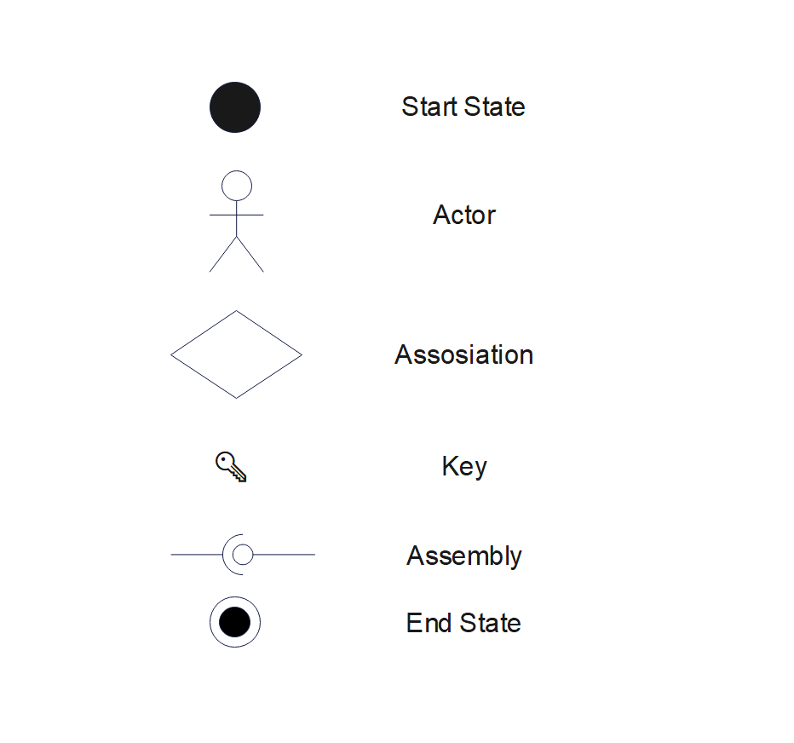

Contents

Approval Sheet i

Acknowledgment ii

Executive Summary iii

Acronyms iv

Symbols v

List of table viii

List of Figure ix

Chapter 1 1

1.1 Introduction 1

1.2 Statement of the Problem and Justification 1

1.3 Objective of the Project 2

1.3.1. General Objective 2

1.3.2. Specific Objectives 2

1.4 System Development Methodology 3

1.4.1. System Development Approach 3

1.4.2. System Development Tools 4

1.5 Scope and Limitation 6

1.6 Significance of the Project 7

1.7 Beneficiaries of the Project 7

1.8 Feasibility Study 8

1.9 Risk Assessment 9

1.10 Work Break Down 10

1.11 Project Budget 10

Chapter 2 11

Requirement Analysis and Specification 11

2.1 Current System Description 11

2.1.1 Major Functions of the Current System 11

2.1.2 Problems of the Existing System 11

2.2 Requirement Gathering 12

2.2.1 Requirement Gathering Methods 12

2.2.2 Business Rules 13

2.3 Proposed System Description 14

2.3.1 Overview 14

2.3.2 Functional Requirements 15

2.3.3 Non-Functional Requirements 15

Chapter 3 17

System Model 17

3.1 Scenario 17

3.1.1 Use Case Model 17

3.1.2 Use Case Diagram 17

3.1.3 Description of Use Case Model 18

3.1.4 Sequence Diagram 29

3.1.5 Activity Diagram 33

3.1.6 Class Model 41

3.1.7 Dynamic Modelling 42

3.1.8 User Interface 42

Chapter 4 45

System Design 45

4.1 Introduction 45

4.2 Purpose of the System 45

4.3 Design Goals 45

4.4 Proposed Software Architecture 45

4.4.1 System Decomposition 46

4.4.2 Hardware/Software Mapping 47

4.4.3 Access Control and Security 47

4.4.4 Deployment Diagram 48

Conclusion 49

Reference 50

# List of table

Table 1‑1 System development tools and their functionalities 5

Table 1‑2 WBD 10

Table 1‑3 Budget 10

Table 3‑1 components of use case diagram 17

Table 3‑2 Use case Description 19

Table 3‑3 Login Description 19

Table 3‑4 Create Account Description 20

Table 3‑5 Add Account Description 21

Table 3‑6 Order Product Description 22

Table 3‑7 Add Product Description 22

Table 3‑8 Delete Product Description 23

Table 3‑9 Edit Account Description 24

Table 3‑10 Edit Product Description 25

Table 3‑11 Search Product Description 25

Table 3‑12 View Status of Ordered Product Description 26

Table 3‑13 View Reports Description 27

# List of Figure

Figure 1.1 Agile workflow diagram 4

Figure 3.2 Use case diagram 18

Figure 3.3 Sequence diagram of Register 29

Figure 3.4 Sequence diagram of Login 29

Figure 3.5 Sequence diagram of Add product 30

Figure 3.6 Sequence diagram of search product 30

Figure 3.7 Sequence diagram of edit product 30

Figure 3.8 Sequence diagram of delete product 31

Figure 3.9 Sequence diagram of add cart 31

Figure 3.10 Sequence diagram of leave review 32

Figure 3.11 Sequence diagram of track order 32

Figure 3.12 Sequence diagram of checkout 32

Figure 3.13 Sequence diagram of view order 33

Figure 3.14 Sequence diagram of logout 33

Figure 3.15 Logout Activity Diagram 34

Figure 3.16 View Report Activity Diagram 34

Figure 3.17 Order Product Activity Diagram 35

Figure 3.18 Edit Product Activity Diagram 35

Figure 3.19 Delete Product Activity Diagram 36

Figure 3.20 View Product Activity Diagram 36

Figure 3.21 Delete Account Activity Diagram 37

Figure 3.22 Add Staff Account Activity Diagram 37

Figure 3.23 Search Activity Diagram 38

Figure 3.24 Login Activity Diagram 39

Figure 3.25 Add Product Activity Diagram 39

Figure 3.26 Edit Account Activity Diagram 40

Figure 3.27 Register Activity Diagram 40

Figure 3.28 Class diagram 41

Figure 3.29 Dynamic model 42

Figure 3.30 Home page 43

Figure 3.31 Login form 44

# Chapter 1

## Introduction

Ethiopia, a land rich in history and tradition, boasts a vibrant culture expressed through its exquisite handcrafted treasures. These aren't just beautiful objects; they're stories woven into form, passed down through generations of skilled artisans. From intricately patterned textiles to delicate beadwork jewelry, each piece reflects regional styles and symbolism, whispering tales of the nation's rich heritage [1].

Imagine vibrant fabrics, hand-woven with intricate designs and rich colors, often incorporating natural dyes and symbolic motifs. Picture functional and decorative baskets meticulously crafted from local materials like sisal, palm leaves, and bamboo [1]. Envision the delicate beauty of jewelry, crafted from precious metals like gold and silver and adorned with intricate beadwork and gemstones. Each piece of pottery, hand-shaped and painted, reflects regional styles and traditional designs [1] [3]. Detailed sculptures and decorative objects, carved from local wood, depict cultural and religious themes [3].

These traditional crafts are more than just a source of income for artisans; they're a vital connection to Ethiopia's past [2]. However, limited market access often hinders these talented individuals from reaching a wider audience and earning a sustainable living [2]. This project proposes a solution: a web-based platform specifically designed to bridge this gap and empower Ethiopian artisans.

## Statement of the Problem and Justification

The rich tradition of Ethiopian handicrafts, a vibrant expression of the country's cultural heritage, faces a significant challenge: limited market reach. This has a detrimental impact on both Ethiopian artisans and the preservation of this art form. Artisans primarily rely on local markets and word-of-mouth, restricting their customer base and income potential. Exacerbating this issue is the absence of a central online marketplace dedicated to Ethiopian crafts. This lack of a digital storefront makes it incredibly difficult for international customers to discover these unique treasures, hindering artisans' opportunities to expand their market reach and connect with a wider audience.. This limited reach has a domino effect. Reduced global exposure results in less appreciation for the artistry, potentially leading to a decline in its cultural significance and a decreased interest from younger generations in pursuing this art form. Furthermore, without a thriving market and broader appreciation, the transmission of traditional knowledge and skills associated with Ethiopian crafts can be jeopardized, risking the loss of valuable cultural heritage and the techniques used to create these pieces.

Our proposed solution is a dedicated e-commerce platform specifically designed for Ethiopian traditional crafts. To bridge the identified gaps, this platform will offer several key features:

A user-friendly platform exclusively showcasing Ethiopian crafts: This ensures artisans have a dedicated space to present their work and reach a global audience.

Interfaces in both Amharic and English: This caters to both local artisans and international customers, fostering wider accessibility and eliminating language barriers.

Culturally relevant design elements: These elements will reflect the beauty and heritage of Ethiopian crafts, enhancing the customer experience and highlighting their significance. By incorporating these design elements, the platform goes beyond simply being a marketplace; it becomes a celebration of Ethiopian culture.

## Objective of the Project

### 1.3.1. General Objective

The main objective of our project is to develop Web based Ethiopian traditional craft E-commerce platform system.

### 1.3.2. Specific Objectives

Our project aims to achieve the following:

* To create a user-friendly platform with streamlined registration and product management.
* To integrate a secure payment gateway using Chapa for international transactions.
* To develop advanced search and filtering functionalities (categories, materials, regions, price).
* To incorporate storytelling elements: product descriptions, high-quality photos, and video snippets.
* To implement a responsive design ensuring compatibility with various devices (desktop, tablet, mobile).
* To set up a customer service system to handle inquiries, complaints, and feedback efficiently.
* To develop custom reporting tools for artisans to track sales, inventory, and customer demographics.
* To ensure the platform is scalable to handle increasing numbers of users and transactions.

## System Development Methodology

### 1.4.1. System Development Approach

The success of our e-commerce platform hinges on a development methodology that fosters adaptability and efficiency.

To achieve this, we'll leverage a powerful combination: Agile development principles and Object-Oriented (OO) design.

**Agile for Continuous Improvement**

Agile methodology prioritizes user feedback throughout the development process. We'll utilize short development sprints to build core functionalities. Following each sprint, user testing sessions will be conducted with Ethiopian artisans and potential customers. This constant feedback loop allows for

Early Identification of Needs: User input after each sprint ensures the platform evolves to meet real-world requirements, preventing wasted development effort.

Continuous Refinement: Based on feedback, functionalities can be refined or new features prioritized within the project scope, ensuring the platform remains relevant and user-friendly.

Adaptability to Change: Unlike Waterfall methodology, Agile allows for adjustments to changing requirements during development. This flexibility is crucial for a dynamic online marketplace, where user needs and trends can evolve rapidly.

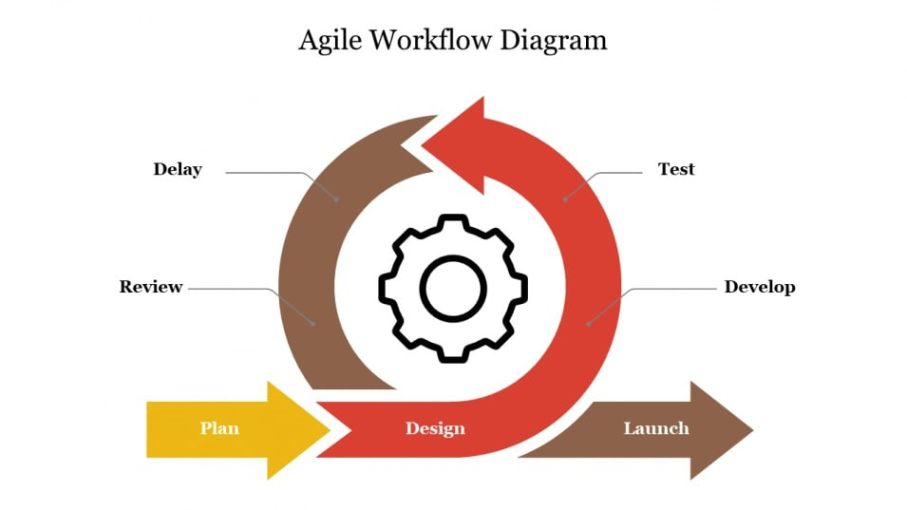

Figure .1 agile workflow diagram

**Object-Oriented Design** **for Efficiency and Maintainability:**

OO design principles will guide our development process. Code will be organized into reusable objects representing real-world entities in the system, like artisans, products, and orders. This approach offers several benefits:

**Efficient Development**: By creating reusable code components, development becomes more efficient, allowing us to build features faster.

**Improved Maintainability**: Clean, modular code with well-defined objects makes future modifications and platform enhancements easier, reducing long-term maintenance costs.

**Scalability for Growth**: As the platform scales and new features are added, the object-oriented structure allows for easier integration without compromising the existing codebases.

By combining Agile development and OO design, we gain a significant advantage. The platform will benefit from continuous user feedback, ensuring it caters to evolving needs. At the same time, the object-oriented approach promotes efficient development and a well-structured codebase, making the platform easier to maintain and adapt to future growth. Ultimately, this combination allows us to create a robust and responsive e-commerce platform that empowers Ethiopian artisans, enhances the customer experience, and fosters the preservation of this valuable cultural heritage.

### 1.4.2. System Development Tools

To effectively develop and implement our e-commerce platform, we plan to utilize the following tools and technologies:

Table 1‑ System development tools and their functionalities

|  |  |  |
| --- | --- | --- |
| Development Stage | Tool | Description |
| Front-End Development | Figma | Design user interface mockups and prototypes for a user-friendly experience. |
| Front-End Development | HTML,CSS,  React | Programming languages to create a responsive web interface based on Figma designs. |
| Back-End Development | Node.js | JavaScript runtime environment for building scalable and real-time web applications. |
| Database Management System (DBMS) | MongoDB | NoSQL document database offering flexibility and scalability for e-commerce applications (stores data). |

**Version Control System**

A version control system like Git to manage code changes, collaborates effectively, and reverts to previous versions if needed.

**Justification for Tool Selection:**

* Our tool selection is driven by both team expertise and project requirements. We'll leverage Figma, a design tool our team is familiar with, to create user-friendly mockups. Our expertise in HTML, CSS, and React will then ensure these mockups translate into a responsive and performant web interface on the front-end. On the back-end, Node.js, a JavaScript runtime environment we're comfortable with, allows us to build a scalable solution for user authentication, product management, payment processing, and order fulfillment. Finally, MongoDB, a NoSQL document database, aligns well with our project's need for flexibility and scalability as the platform grows in product variety and user base..

## Scope and Limitation

**Scope**

**Boundaries:**

* The platform is designed for Ethiopian artisans who create traditional crafts. They can use the platform to showcase and sell their work to a global audience.
* The platform targets international customers interested in purchasing Ethiopian traditional crafts. This includes anyone around the world who appreciates unique, handcrafted items.
* The platform will encompass various categories of Ethiopian traditional crafts, such as woven textiles, pottery, jewelry, baskets, and wood carvings.
* Secure payment processing will be integrated for smooth and reliable Trans, including support for Chapa, a popular Ethiopian payment gateway.

**Functionalities:**

**User-Friendly Platform**

* **Registration** (Create): Both artisans and customers can create accounts (optional for customers) for a personalized experience.
* **Product Management** (CRUD): Artisans can add (Create), edit (Read & Update), and remove (Delete) product listings, including descriptions, photos, and pricing. They can also track inventory levels.
* **Shopping**: Customers can browse products, add items to their carts, and proceed through a secure checkout process with various payment options.
* **Tracking**: Both artisans and customers can track the status of their orders and receive updates on fulfilment.
* **Reporting**: The platform will offer reporting functionalities for both artisans and Admins. This allows artisans to generate reports on sales performance, product popularity, and customer demographics. Admins can generate reports on platform usage, user activity, and overall performance metrics.

**Limitations:**

* **Limited Languages:** The platform will initially launch in English and Amharic. We'll add more languages in the future to reach a wider audience.
* **Accessibility Features:** We're committed to making the platform accessible to everyone. However, extensive features for visually impaired users might be limited in the initial launch.
* **Payment Options:** We'll prioritize secure and trusted payment options like Chapa to ensure smooth Trans. International payment options may be added later based on user needs and resource availability.

## Significance of the Project

This e-commerce platform aims to be a powerful tool for promoting Ethiopian culture, saving artisans time and resources, while maximizing positive impact within the initial development timeframe.

* **Global Marketplace:** The platform prioritizes core functionalities to establish a global online marketplace, connecting artisans with international customers. This bypasses limitations of local markets, saves them time finding buyers, and increases income potential.
* **Sustainable Livelihoods:** By facilitating sales and future growth, the platform contributes to the economic sustainability of traditional crafts.
* **Empowerment through Control:** Artisans gain control over their online presence by setting prices and managing product listings, fostering a sense of ownership and reducing reliance on intermediaries.

## Beneficiaries of the Project

The e-commerce platform empowers a range of stakeholders, fostering a positive ripple effect:

* **Ethiopian Artisans**: Gain access to a global market, increase sales potential, and achieve greater economic independence.
* **International Customers**: Discover a user-friendly platform offering a curated selection of authentic Ethiopian crafts, enriching their cultural appreciation and providing access to unique treasures.
* **Tourism Industry**: The platform acts as a vibrant showcase of Ethiopian cultural heritage, potentially attracting tourists interested in experiencing these traditions first-hand.
* **Preservation of Cultural Heritage**: The platform's focus on traditional crafts contributes to their survival and continued practice, ensuring their cultural significance for future generations.
* **Local Communities**: The success of artisans can have a positive impact on their communities by generating income, promoting cultural pride, and potentially attracting investments that benefit local infrastructure or skill development programs.

## Feasibility Study

This feasibility study examines the potential of an e-commerce platform for Ethiopian artisans, focusing on key benefits, challenges, and considerations.

### A. Technical Feasibility

1. **Technical Expertise**:
   * **Assessment**: The development team needs to be evaluated for their skills and experience in the required technologies.
   * **Plan**: Review the team's proficiency in relevant programming languages (e.g., HTML, CSS, JavaScript), databases (e.g., MongoDB), and e-commerce frameworks (e.g., Node.js).
2. **Technology Availability**:
   * **Assessment**: Ensure the necessary development tools, libraries, and cloud platforms are accessible and within budget.
   * **Plan**: Identify and procure the required software and cloud services, such as Figma for UI design, and Git for version control.
3. **System Integration**:
   * **Assessment**: Evaluate the platform's ability to integrate with existing systems like payment gateways (e.g., Chapa) and shipping services.
   * **Plan**: Develop integration modules and perform testing to ensure seamless operation and positive user experience.

### B. Economic Feasibility

1. **Tangible Benefits**:
   * **Increased Sales for Artisans**:
     + **Benefit**: Higher income and economic empowerment for artisans, potentially creating new jobs.
     + **Measurement**: Track sales growth and job creation metrics.
   * **Reduced Costs for Artisans**:
     + **Benefit**: Lower selling costs due to elimination of intermediaries and access to a wider market.
     + **Measurement**: Monitor expense reduction and cost savings.
2. **Non-Tangible Benefits**:
   * **Preservation of Cultural Heritage**:
     + **Benefit**: Enhanced appreciation of traditional crafts, potentially boosting cultural tourism.
     + **Measurement**: Qualitative feedback and cultural tourism statistics.
   * **Empowerment of Artisans**:
     + **Benefit**: Greater control over businesses, fostering ownership and entrepreneurial spirit.
     + **Measurement**: Qualitative feedback and artisan engagement metrics.

### C. Operational Feasibility

* **Assessment**: Ensure the system will be efficient and user-friendly.
* **Plan**: Develop a well-designed user interface and conduct usability testing to ensure accessibility and ease of operation.

### D. Political Feasibility

1. **Political Stability**:
   * **Assessment**: Evaluate Ethiopia's political climate and its impact on the project (e.g., internet access disruptions).
   * **Plan**: Develop contingency plans for political instability and ensure reliable internet access.
2. **Government Regulations**:
   * **Assessment**: Research import/export regulations and e-commerce policies.
   * **Plan**: Ensure compliance with relevant regulations and address any potential legal challenges.

### E. Schedule Feasibility

* **Assessment**: Determine if the project can be completed within the proposed timeline.
* **Plan**: Create a detailed project schedule, allocate resources effectively, and set realistic deadlines to ensure timely completion.

## Risk Assessment

**Risk**

The new system has some risks. Some of these are:

* Loss of data because of failure of server.
* Loss of file because of virus.
* Loss of file because of carelessness.

So that the above problems might require some kind of management and we had put some

Methods down: -

* We would have backup using hard disk (hard drives) so that, the data could not be loss
* We would use antivirus if we might get the updated one
* As much as possible we would try to used day and nights

## Work Break Down

Table 1‑ WBD

|  |  |  |  |  |  |
| --- | --- | --- | --- | --- | --- |
| **Task Name** | **Time** | | | | |
| Apr 15 –May 9 2024 GC | May 10 - 25 2024 GC | May 26 – 31 2024 GC | June 1 – Oct 15 2024 GC | Oct 16 2024 GC |
| **Project proposal** |  |  |  |  |  |
| **Requirement analysis** |  |  |  |  |  |
| **Design** |  |  |  |  |  |
| **Implementation** |  |  |  |  |  |
| **Testing** |  |  |  |  |  |

## Project Budget

This represents a cost of different materials that we need to do our project. It represented as follows:

Table 1‑ Budget

|  |  |  |  |
| --- | --- | --- | --- |
| **Material** | **Amount** | **Single Price (in ET birr)** | **Total Price (in ET birr)** |
| Paper | 40 | 2 | 80 |
| Pen | 5 | 20 | 100 |
| Flash (16 GB) | 1 | 350 | 350 |
| Print |  | 5 | 300 |
| Others |  | 100 | 100 |
| Total | | | 930 |

# Chapter 2

# Requirement Analysis and Specification

## Current System Description

### Major Functions of the Current System

The current system for selling Ethiopian traditional crafts operates primarily in offline marketplaces where artisans engage directly with customers. This system revolves around face-to-face inters at local markets, craft fairs, and cultural festivals. Artisans display their products in these venues, offering immediate purchase options to customers. The system’s major functions include direct sales, where artisans sell products in person, and manual inventory management, where stock levels are tracked through handwritten logs or simple spread sheets. Cash Trans are the norm, limiting the scope for digital payment records. Marketing efforts are predominantly local, relying on word-of-mouth, small-scale advertisements, and participation in community events [3]. Customer inters are highly personal, fostering strong local relationships but restricting the broader market reach [3]. This setup, while culturally rich and personally engaging, lacks the efficiency, scalability, and broader accessibility that modern technology can provide [2] [3].

### Problems of the Existing System

The existing system faces several challenges that hinder its efficiency and growth potential. The most significant issue is the limited reach, as artisans can only sell to customers who can physically visit the local markets. This geographical constraint severely limits their market size and sales opportunities. Additionally, the absence of an online presence means that artisans are missing out on potential customers from outside their immediate vicinity, including international buyers who might be interested in unique Ethiopian crafts.

Manual processes for order handling introduce inefficiencies and increase the likelihood of errors. Tracking orders and managing customer information on paper or simple spread sheets is time-consuming and prone to mistakes. The reliance on cash Trans further limits the customer base and complicates the sales process. Furthermore, the limited sales opportunities and income constraints pose a risk to the continuation of traditional crafts. Without sufficient income, artisans may be forced to abandon their craft, leading to a potential loss of cultural heritage.

While the current system allows for personal inter and immediate sales, it suffers from several significant issues:

* **Limited Market Reach**: Artisans can only sell to local customers, missing out on a broader national and international market.
* **Inventory Errors**: Manual inventory tracking leads to frequent errors and mismanagement, resulting in stock outs or overstocking.
* **Dependency on Cash**: Cash Trans limit the potential for sales, as they require physical presence and exclude online customers.
* **Inadequate Marketing**: Limited marketing channels reduce customer awareness and demand for products.
* **Inefficient Order Processing**: No formal system exists for managing orders, leading to delays and errors in fulfilling customer requests.
* **Security Issues**: Cash handling increases the risk of theft and financial loss.

## Requirement Gathering

### Requirement Gathering Methods

To develop an effective online platform for Ethiopian traditional crafts, a comprehensive requirement gathering process was undertaken. This involved multiple methods to ensure a thorough understanding of the needs and challenges faced by all stakeholders.

**Surveys**

Surveys were distributed to potential customers to collect quantitative data on their buying habits, preferences, and willingness to shop online. Questions focused on their frequency of purchasing traditional crafts, preferred payment methods, and factors influencing their buying decisions. The survey results provided a broad overview of customer behaviour and preferences, helping to validate the findings from the interviews.

**Workshops**

Workshops were organized to bring together stakeholders, including artisans, customers, and technical experts. These sessions facilitated collaborative brainstorming on the features and functionalities needed in the new system. Participants discussed their experiences, pain points, and aspirations for the online platform. Workshops provided a dynamic environment for idea generation and consensus building, ensuring that the proposed system would meet diverse needs.

**Observations**

Field observations were conducted at local markets and craft fairs to observe the current sales processes and inters between artisans and customers. This method provided firsthand insights into the operational challenges and inefficiencies of the existing system. Observations highlighted issues such as inventory mismanagement, dependency on cash Trans, and limited marketing reach. These insights were crucial for identifying areas where the new system could provide significant improvements.

**Competitive Analysis**

A competitive analysis was performed to examine similar e-commerce platforms and identify best practices that could be applied to the new system. The analysis included studying the features, user interfaces, and functionalities of successful online marketplaces for crafts and artisanal products. This helped identify potential features for the proposed platform, such as secure payment processing, efficient order management, and user-friendly interfaces. By understanding what works well in other platforms, we could tailor our system to offer a competitive edge in the market.

### Business Rules

The proposed system will incorporate several business rules to ensure its functionality and security. User registration will be mandatory for both artisans and customers to access platform features, ensuring accountability and secure Trans. Artisans will be able to create detailed product listings, including descriptions, prices, and images, providing customers with essential information to make informed purchase decisions.

Customers will benefit from advanced search functionality, allowing them to find products using various filters. Secure payment integration with gateways like Chapa will protect financial Trans, enhancing trust and security for both artisans and customers. To cater to a diverse audience, the platform will support both Amharic and English, making it accessible to local and international users.

#### SWOT Analysis

A SWOT analysis was conducted to evaluate the internal strengths and weaknesses of the current system, as well as external opportunities and threats.

**Strengths**

* Strong personal relationships with local customers.
* Skilled artisans with deep knowledge of their craft.

**Weaknesses**

* Limited market reach and customer base.
* Manual processes prone to errors.
* Dependency on cash Trans.

**Opportunities**

* Expanding to online sales to reach a global market.
* Utilizing digital marketing to increase brand awareness.

**Threats**

* Cyber security risks associated with online trans.
* Resistance to change from artisans accustomed to traditional sales methods.

## Proposed System Description

### Overview

The proposed system is a web-based e-commerce platform designed to connect Ethiopian artisans with a global audience. This platform will enable artisans to showcase and sell their products online, thereby expanding their market reach and increasing their income potential. It aims to address the limitations of the current system by leveraging modern technology to streamline operations, enhance market reach, and improve customer experience. By creating a centralized online marketplace, the platform aims to bridge the gap between artisans and customers, providing a convenient and efficient way to buy and sell traditional crafts.

### Functional Requirements

These requirements are the basic for the system or simply functional requirements that the system should satisfy. According to the tasks that the system we develop will do the following activities.

**Admins:**

* User Management: Manage artisan and customer accounts.
* Product Management: Oversee product listings and inventory.
* Order Management: Monitor order processing and fulfillment.
* Analytics: Generate reports on sales, inventory, and user activities.
* Security Management: Ensure data security and manage access controls.

**Artisans:**

* User Management: Secure registration and login for artisans.
* Product Listings: Ability to add, edit, and delete product listings.
* Inventory Management: Automated tracking of product quantities and stock levels.
* Order Management: Efficient handling of order placements and updates.
* Customer Inter: Ability to view and respond to customer reviews and inquiries.

**Customers:**

* User Management: Secure registration and login for customers.
* Product Browsing: Search and filter products by category, price, and ratings.
* Order Placement: Simple and secure order placement process.
* Order Tracking: Real-time order tracking.
* Payment Processing: Multiple payment options including credit/debit cards and digital wallets.
* Customer Support: Access to customer support for inquiries and issues.

### Non-Functional Requirements

These requirements define the overall qualities or attributes of the system:

**Performance**

* **Fast Response Times**: Ensure the platform provides quick response times for user interactions and transactions.
* **Efficient Handling**: Capable of managing high traffic and large volumes of data efficiently.

**Environmental**

* **Compatibility**: Ensure the platform is compatible with various web browsers and devices.
* **Sustainability**: Utilize sustainable and low-energy-consuming server infrastructure.

**Usability**

* **Intuitive Interface**: Develop an intuitive user interface with clear navigation.
* **Accessibility**: Design for accessibility, accommodating users with disabilities.

**Security**

* **Data Encryption**: Implement data encryption for secure transactions.
* **Security Audits**: Conduct regular security audits and updates to ensure ongoing protection.

**Maintainability**

* **Modular Architecture**: Design a modular architecture to facilitate easy updates and maintenance.
* **Documentation**: Provide comprehensive documentation for developers.

**Reliability**

* **High Uptime**: Ensure high uptime and availability of the platform.
* **Backup and Recovery**: Implement robust backup and disaster recovery mechanisms.

**Availability**

* **24/7 Access**: Ensure the platform is accessible 24/7.
* **Redundant Infrastructure**: Deploy redundant server infrastructure to prevent downtime.

**Interoperability**

* **Third-Party Integration**: Enable integration with third-party services, such as payment gateways and shipping services.
* **Standardized APIs**: Provide standardized APIs for external interactions.

**Scalability**

* **User Growth**: Ensure the platform can handle increasing numbers of users and transactions.
* **Scalable Infrastructure**: Implement a scalable infrastructure to support growth.

# Chapter 3

# System Model

## Scenario

### Use Case Model

The use case model outlines the inters between actors (admin, artisans, and customers) and the system. Actors will be able to register and create accounts, enabling them to access platform features. Artisans will add, edit, and delete product listings, while customers will search for products, view details, and add items to their shopping cart. The checkout process will handle secure payment Trans, and both artisans and customers will be able to track order statuses. Customers can also leave reviews and ratings for products, providing valuable feedback for artisans and helping other buyers make informed decisions.

### Use Case Diagram

A use case is a description of a system’s behavior as it responds to a request from one of its stakeholders, typically an actor or a user. It encapsulates functional requirements by specifying a series of s performed by the system that yields an observable result of value to the actor. Each use case is a high-level description that includes the inters between the actor and the system, focusing on what the system should do, not how it should be implemented [4].

Table 3‑ components of use case diagram

|  |  |
| --- | --- |
| **Actor** | Use Case Diagram Notation - Actor |
| **Use Case** | Use Case Diagram Notation - Use Case |
| **Communication Link**. |  |
| **Boundary of system** | Use Case Diagram Notation - System Boundary |

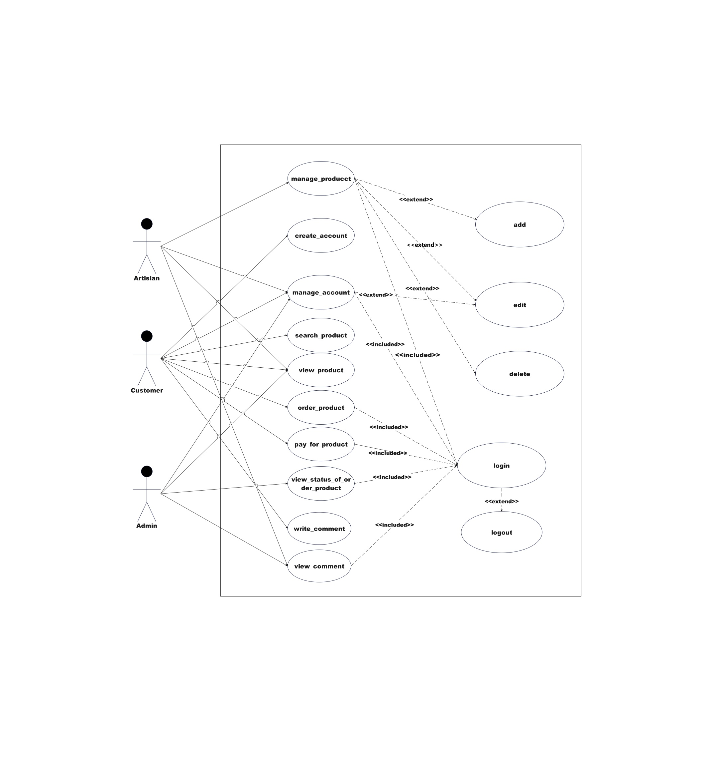

Figure 3.2 Use case diagram

### Description of Use Case Model

The use case model includes several key inters. Users will register by providing necessary details, enabling them to create an account and access the platform. The login process will authenticate users, ensuring that only registered users can access the system. Artisans will add new products by filling out product details and uploading images, while the edit and delete functions will allow them to maintain an accurate and current product catalogue. Customers will search for products using keywords and filters, view detailed product descriptions and images, and add items to their shopping cart. The checkout process will handle secure payment Trans, and users will be able to track the status of their orders. Finally, the review and rating system will allow customers to provide feedback on products, enhancing the overall user experience.

Table 3‑ Use case Description

|  |  |  |
| --- | --- | --- |
| **Use Case** | **Actor** | **Description** |
| Register | Customer, Artisan | Users sign up by providing necessary details. |
| Login | Customer, Artisan | Users log in to access their accounts. |
| Add Product | Artisan | Artisans add new products to their inventory. |
| Edit Product | Artisan | Artisans update product details. |
| Delete Product | Artisan | Artisans remove products from their listings. |
| Search Products | Customer | Customers search for products using filters. |
| Add to Cart | Customer | Customers add products to their shopping cart. |
| Checkout | Customer | Customers complete the purchase process. |
| Track Order | Customer | Customers track the status of their orders. |
| Leave Review | Customer | Customers provide feedback on products. |
| View Orders | Artisan | Artisans view orders placed by customers. |

Table 3‑ Login Description

|  |  |  |
| --- | --- | --- |
| **Use Case ID** | UC-01 | |
| **Name** | Login | |
| **Actor(s)** | Customer, Admin, Artisan | |
| **Description** | This use case describes how users log into the system. Users must enter their credentials to access the system. The system validates the credentials and grants access if they are correct. | |
| **Preconditions** | Users must have an existing account with a valid username and password. | |
| **Post conditions** | Users are successfully logged into the system and redirected to their respective dashboard. | |
| Basic course of Action | **User** | **System Response** |
| 1. User opens the website. | 2. The system displays the homepage. |
| 3. User clicks the login button. | 4. The system displays the login form. |
| 5. User fills in their username and password. | 6. The system verifies the username and password. |
| 7. User clicks the login button. | 8. The system redirects the user to the appropriate dashboard. |
| Alternative course | If the login name or password is not valid  6.1 The login page is redisplayed.  6.2 Go to step 5 and fill in the credentials again.  6.3 The system provides an option to reset the password if necessary. | |

Table 3‑ Create Account Description

|  |  |  |
| --- | --- | --- |
| Use Case ID | UC-02 | |
| Use Case Name | Create Account | |
| Actor(s) | User (Customer or Artesian) | |
| Description | A new user registers an account by providing necessary details like name, email, and password. The system creates a new account and sends a confirmation email. | |
| Preconditions | User must not already have an account. | |
| Post conditions | A new user account is created, and the user is notified via email. | |
| Basic course of Action | **User** | **System Response** |
| 1. User navigates to the registration page. | 2. The system displays the registration page. |
| 1. User fills in required details. | 1. The system validates the information provided. |
| 5. System validates information. | - |
| * 1. Account is created and confirmation email is sent. | * 1. The system creates a new account and sends a confirmation email. |
| Alternative course | 4.1 If required details are missing, an error message is displayed.  Go to step 3 and fill in the details again.  The user corrects the missing details and resubmits | |

Table 3‑ Add Account Description

|  |  |  |
| --- | --- | --- |
| Use Case ID | UC-03 | |
| Name | Add Account | |
| Actor(s) | Admin | |
| Description | An Admin adds a new account for a user manually into the system, specifying details like username, email, and role. The system verifies the information and adds the account. | |
| Preconditions | Admin must be logged into the system. | |
| Post conditions | A new user account is created by the Admin. | |
| Basic course of Action | **User** | **System Response** |
| 1. Admin navigates to add account page. | 2. The system displays the add account page. |
| 3. Admin fills in required user details. | 4. The system validates the information provided. |
| 5. System verifies information. | - |
| 6. Account is added to the system. | 7. The system adds the new user account. |
| Alternative course | 4.1 If required details are missing the system displays an error message indicating missing details.  Go to step 3 and fill in the details again. | |

Table 3‑ Order Product Description

|  |  |  |
| --- | --- | --- |
| Use Case ID | UC-04 | |
| Name | Order Product | |
| Actor(s) | Customer | |
| Description | A customer places an order for a product by selecting it from available options, specifying quantity, and confirming the order. The system processes the order and updates inventory. | |
| Preconditions | Customer must be logged into the system and have selected products in the shopping cart. | |
| Post conditions | Order is placed successfully, and inventory is updated. | |
| Basic course of Action | **User** | **System Response** |
| 1. Customer navigates to product ordering page. | 2. The system displays available products. |
| 3. Customer selects product and specifies quantity. | 4. The system adds selected product to shopping cart. |
| 5. Customer confirms order. | 6. The system processes the order and updates inventory. |
| Alternative course | If inventory is insufficient  The system notifies the customer about the insufficient inventory.  Customer adjusts the order quantity or selects alternative products.  Go to step 1 and update the order details. | |

Table 3‑ Add Product Description

|  |  |  |
| --- | --- | --- |
| Use Case ID | UC-05 | |
| Name | Add Product | |
| Actor(s) | Admin | |
| Description | An Admin adds a new product to the system catalogue, providing details such as name, description, price, and available quantity. The system validates the information and adds the product to the catalogue. | |
| Preconditions | Admin must be logged into the system. | |
| Post conditions | A new product is added to the system catalogue. | |
| Basic course of Action | **User** | **System Response** |
| 1. Admin navigates to add product page. | 2. The system displays the add product page. |
| 3. Admin fills in required product details. | 4. The system validates the information provided. |
| 5. System verifies information. | - |
| 6. Product is added to the catalogue. | 7. The system adds the new product to the catalogue. |
| Alternative course | If required details are missing  The system displays an error message indicating missing details.  Admin corrects the missing details and resubmits.  Go to step 3 and fill in the details again. | |

Table 3‑ Delete Product Description

|  |  |  |
| --- | --- | --- |
| Use Case ID | UC-06 | |
| Name | Delete Product | |
| Actor(s) | Admin | |
| Description | An Admin deletes a product from the system catalogue. The system removes the product from the catalogue and updates inventory accordingly. | |
| Preconditions | Admin must be logged into the system. | |
| Post conditions | The product is successfully deleted from the system catalogue. | |
| Basic course of Action | **User** | **System Response** |
| 1. Admin navigates to delete product page. | 2. The system displays the delete product page. |
| 3. Admin selects the product to delete. | 4. The system confirms the deletion request. |
| 5. System removes the product from the catalogue. | 6. The system updates inventory. |
| Alternative course | If product deletion is restricted  The system notifies the Admin about the restriction.  Admin resolves dependencies or contacts support for assistance.  Retry step 3 after resolving dependencies. | |

Table 3‑ Edit Account Description

|  |  |  |
| --- | --- | --- |
| Use Case ID | UC-07 | |
| Name | Edit Account | |
| Actor(s) | Admin | |
| Description | An Admin edits an existing user account details, such as username, email, or role, in the system. The system verifies the changes and updates the account information. | |
| Preconditions | Admin must be logged into the system. | |
| Post conditions | The user account details are successfully updated in the system. | |
| Basic course of Action | **User** | **System Response** |
| 1. Admin navigates to edit account details page. | 2. The system displays the edit account details page. |
| 2. Admin makes changes to account details. | 4. The system validates the updated information. |
| 3. System updates the account with new information. | 6. The system confirms successful update. |
| Alternative course | If account deletion is restricted  The system notifies the Admin about the restriction.  Admin completes or reassigns tasks associated with the account.  Retry step 3 after completing or reassigning tasks. | |

Table 3‑ Edit Product Description

|  |  |  |
| --- | --- | --- |
| Use Case ID | UC-08 | |
| Name | Edit Product | |
| Actor(s) | Admin | |
| Description | An Admin edits details of an existing product in the system catalogue, such as name, description, price, or quantity. The system verifies the changes and updates the product information. | |
| Preconditions | Admin must be logged into the system. | |
| Post conditions | The product details are successfully updated in the system catalogue. | |
| Basic course of Action | **User** | **System Response** |
| 1. Admin navigates to edit product details page. | 2. The system displays the edit product details page. |
| 3. Admin makes changes to product details. | 4. The system validates the updated information. |
| 5. System updates the product with new information. | 6. The system confirms successful update. |
| Alternative course | If required details are missing or invalid  The system displays an error message indicating the issue.  Admin corrects the missing or invalid details and resubmits.  Go to step 3 and update the product details again. | |

Table 3‑ Search Product Description

|  |  |  |
| --- | --- | --- |
| Use Case ID | UC-9 | |
| Name | Search Product | |
| Actor(s) | Customer, Admin | |
| Description | Users search for a specific product in the system catalogue using keywords or filters. The system displays relevant search results based on the search criteria. | |
| Preconditions | User must be logged into the system. | |
| Post conditions | User views search results matching the specified criteria. | |
| Basic course of Action | **User** | **System Response** |
| 1. User enters search keywords or applies filters. | 2. The system performs a search based on the entered keywords or applied filters. |
| 3. System displays search results. | 4. The system shows a list of products matching the search criteria. |
| Alternative course | If no results match the search criteria  The system notifies the user about no matching products.  User adjusts search keywords or filters.  Retry step 1 with adjusted criteria. | |

Table 3‑ View Status of Ordered Product Description

|  |  |  |
| --- | --- | --- |
| Use Case ID | UC-10 | |
| Name | View Status of Ordered Product | |
| Actor(s) | Customer | |
| Description | Customers view the status of their ordered product(s) to track the progress of delivery. The system displays current status information, such as processing, shipped, or delivered. | |
| Preconditions | Customer must be logged into the system and have placed an order. | |
| Post conditions | Customer views the current status of their ordered product(s). | |
| Basic course of Action | **User** | **System Response** |
| 1. Customer navigates to order status page. | 2. The system displays a list of ordered products and their current status. |
| 3. Customer views status information. | 4. The system shows the current status of each ordered product. |
| Alternative course | If no status information is available  The system notifies the customer about the delay.  Customer contacts support for further assistance.  Retry step 1 after resolving the issue. | |

Table 3‑ View Reports Description

|  |  |  |
| --- | --- | --- |
| Use Case ID | UC-11 | |
| Name | View Reports | |
| Actor(s) | Admin | |
| Description | Admins view various reports generated by the system, such as sales reports, inventory reports, or customer activity reports. The system presents detailed data and insights based on selected report criteria. | |
| Preconditions | Admin must be logged into the system. | |
| Post conditions | Admin views detailed reports and data insights as per selected criteria. | |
| Basic course of Action | **User** | **System Response** |
| 1. Admin navigates to view reports section. | 2. The system displays a list of available reports. |
| 3. Admin selects a report to view and specifies criteria. | 4. The system generates the selected report based on specified criteria. |
| 5. System presents detailed report and data insights. | 6. The system provides detailed information and insights based on the generated report. |
| Alternative course | If selected report criteria are invalid  The system notifies the Admin about the invalid criteria.  Admin adjusts report criteria.  Retry step 3 with corrected criteria. | |

### Sequence Diagram

A sequence diagram is a type of inter diagram that shows how processes operate with one another and in what order. It represents the sequence of messages exchanged between objects needed to carry out the functionality of a use case. Sequence diagrams illustrate the inters between objects over time, focusing on the order of messages rather than the details of message contents [5].

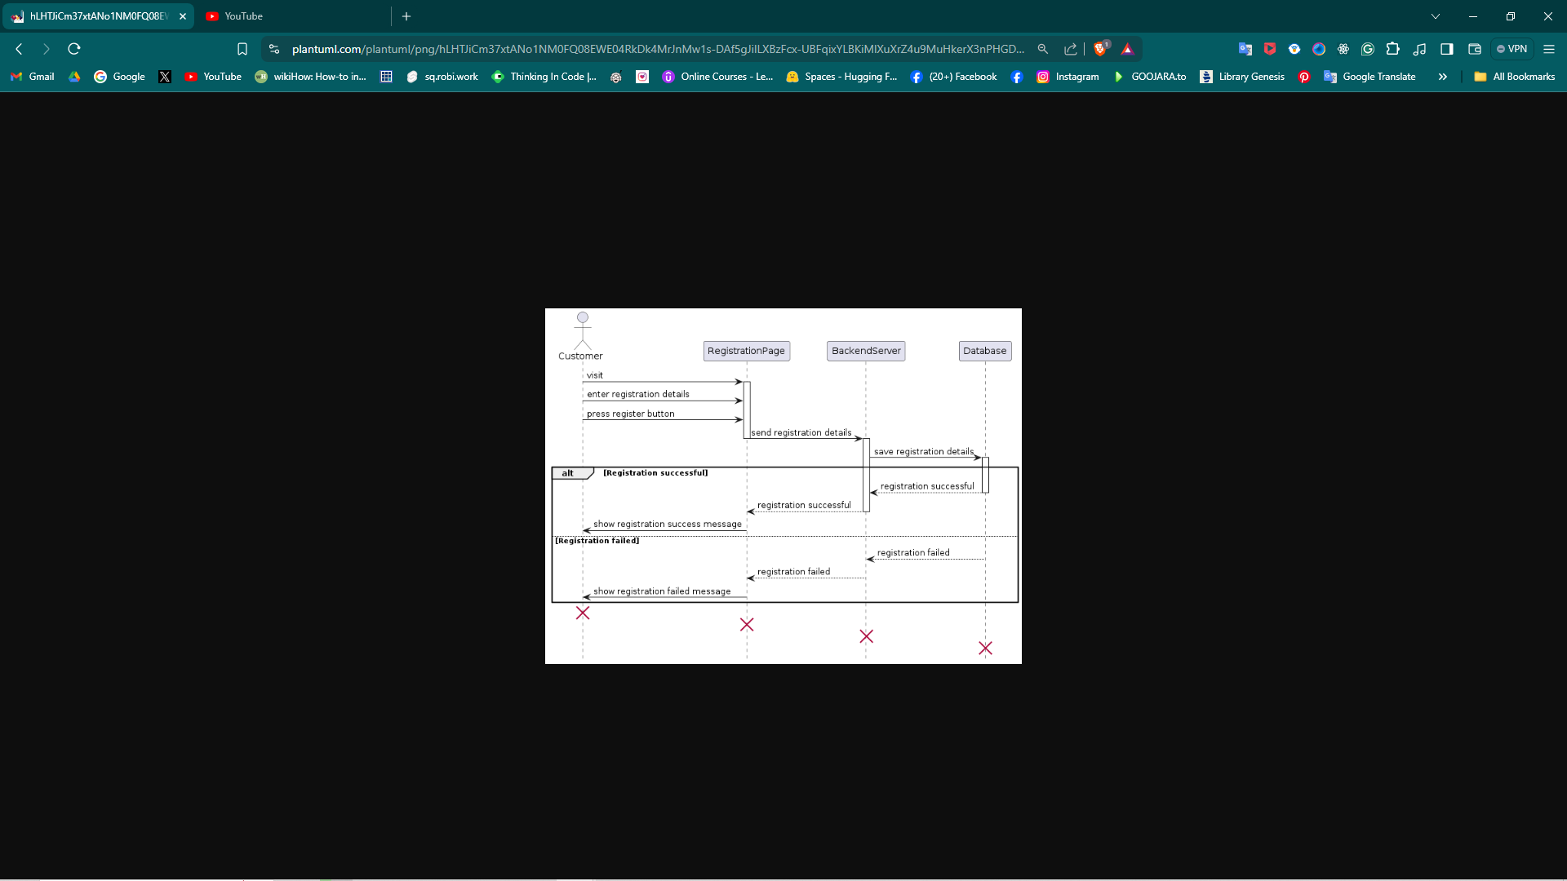

Figure 3.3 Sequence diagram of Register

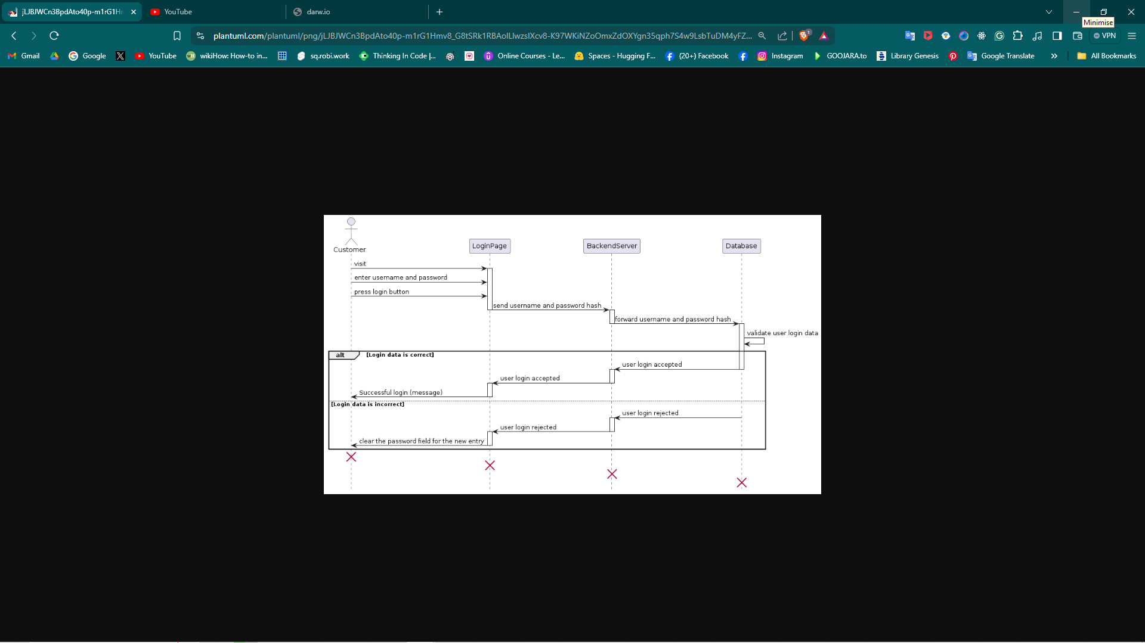

Figure 3.4 Sequence diagram of Login

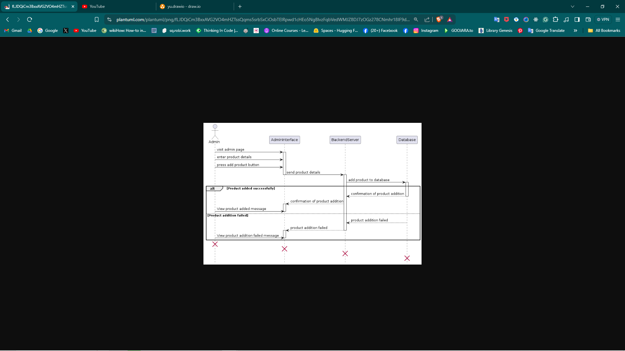

Figure 3.5 Sequence diagram of Add product

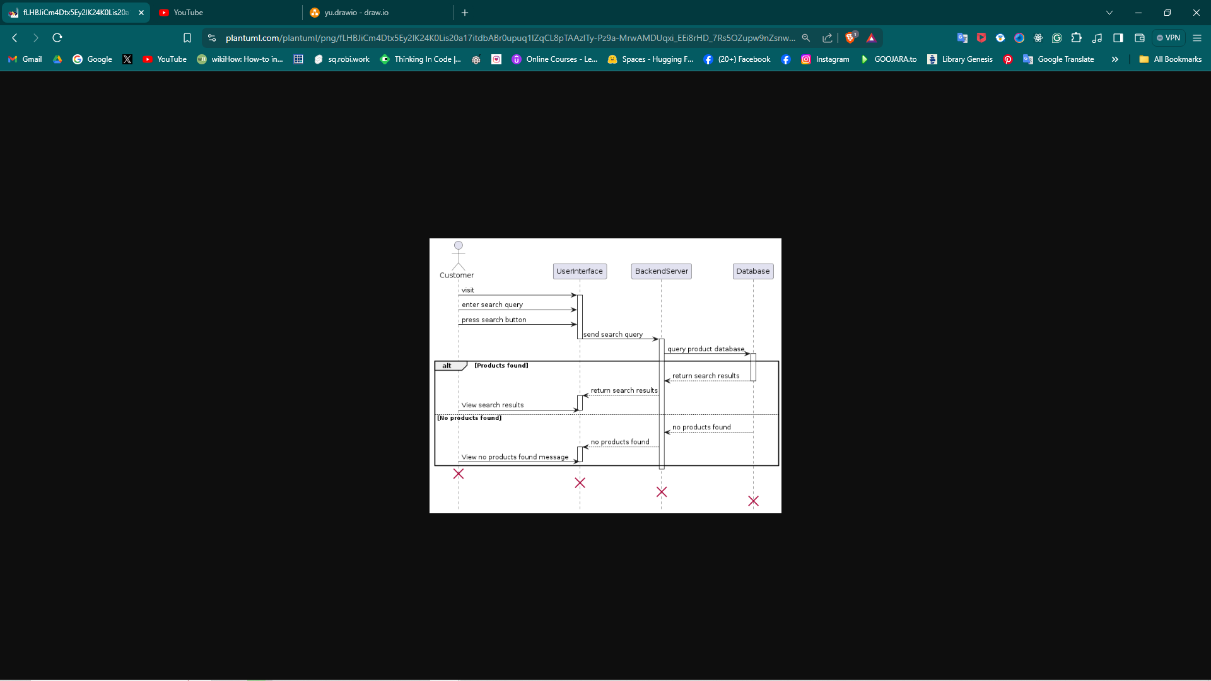

Figure 3.6 Sequence diagram of search product

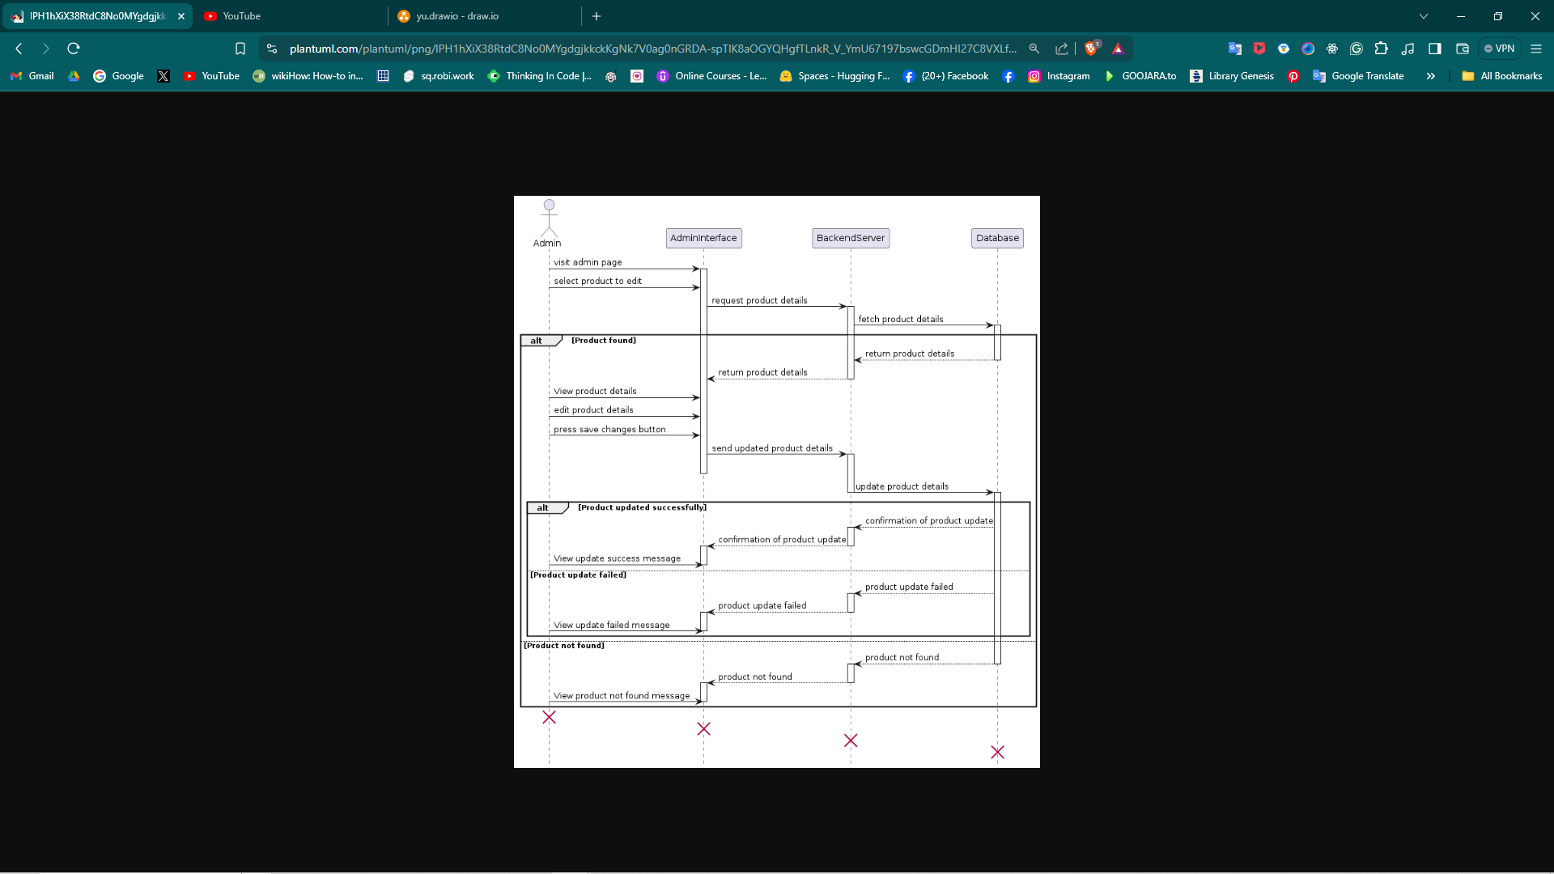

Figure 3.7 Sequence diagram of edit product

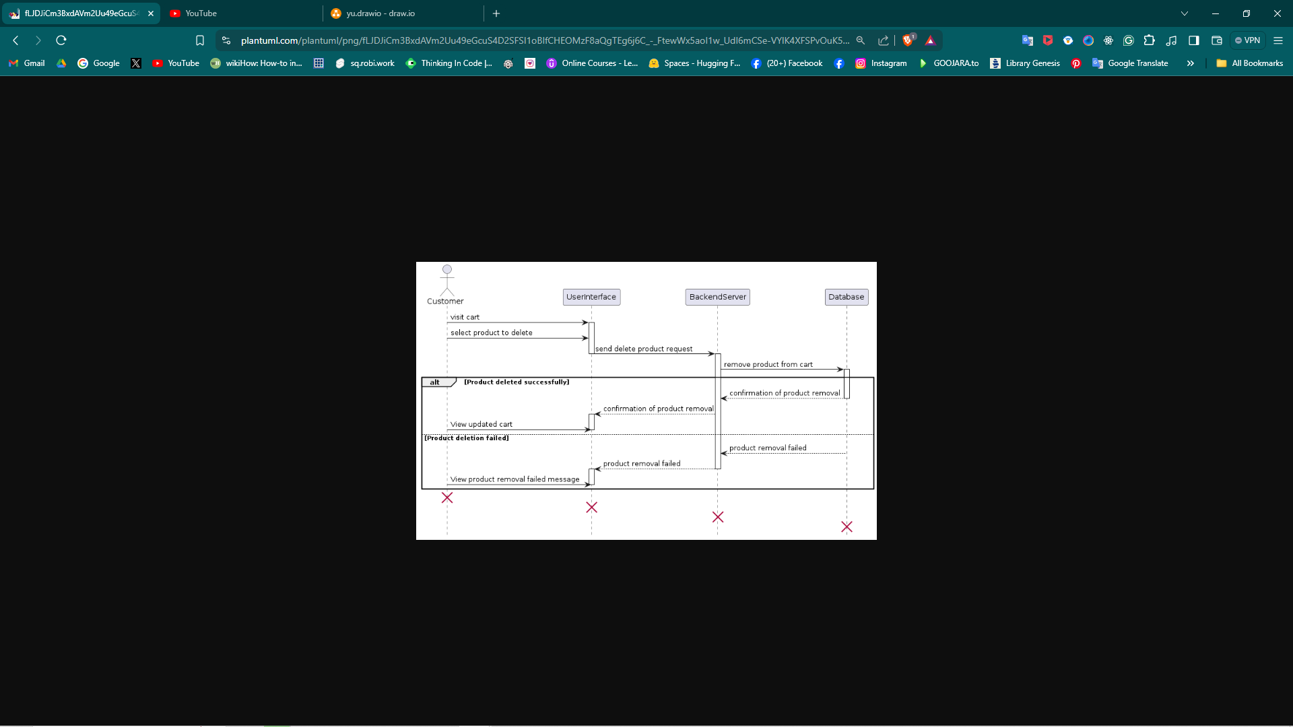

Figure 3.8 Sequence diagram of delete product

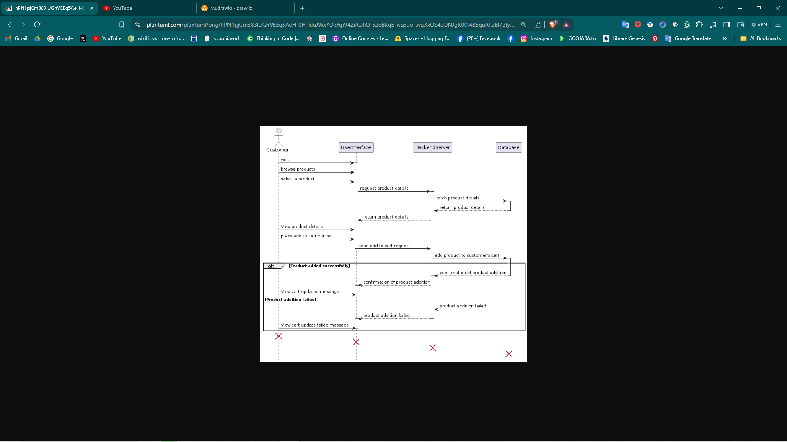

Figure 3.9 Sequence diagram of add cart

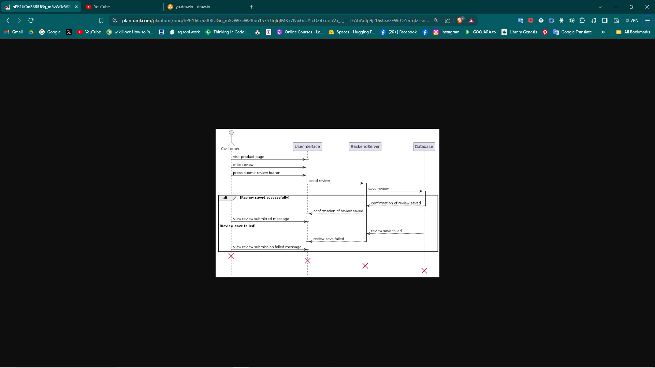

Figure 3.10 Sequence diagram of leave review

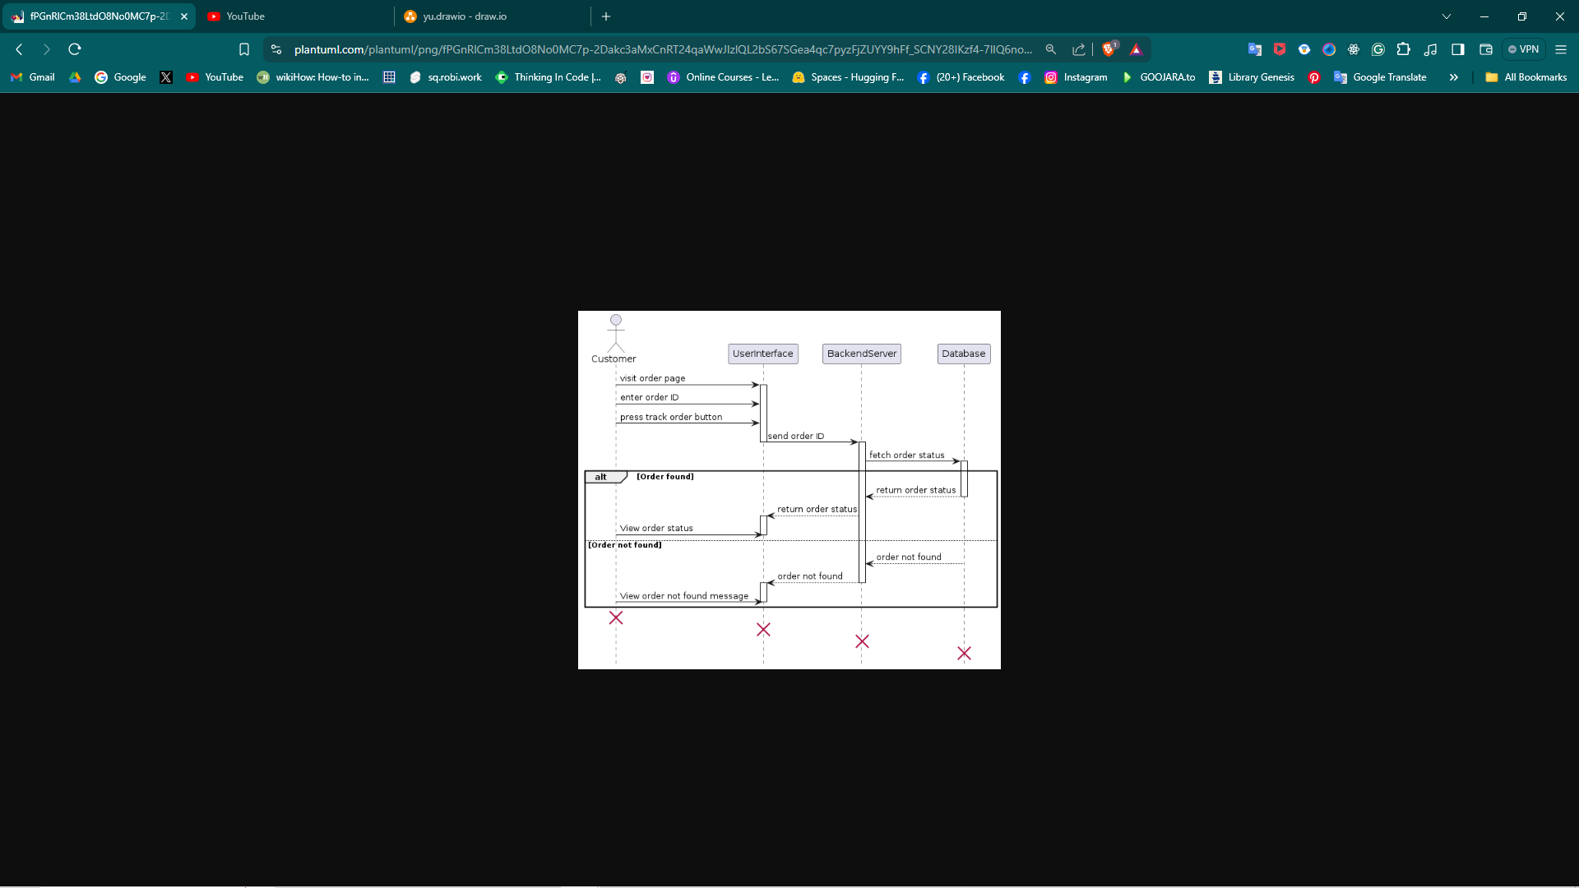

Figure 3.11 Sequence diagram of track order

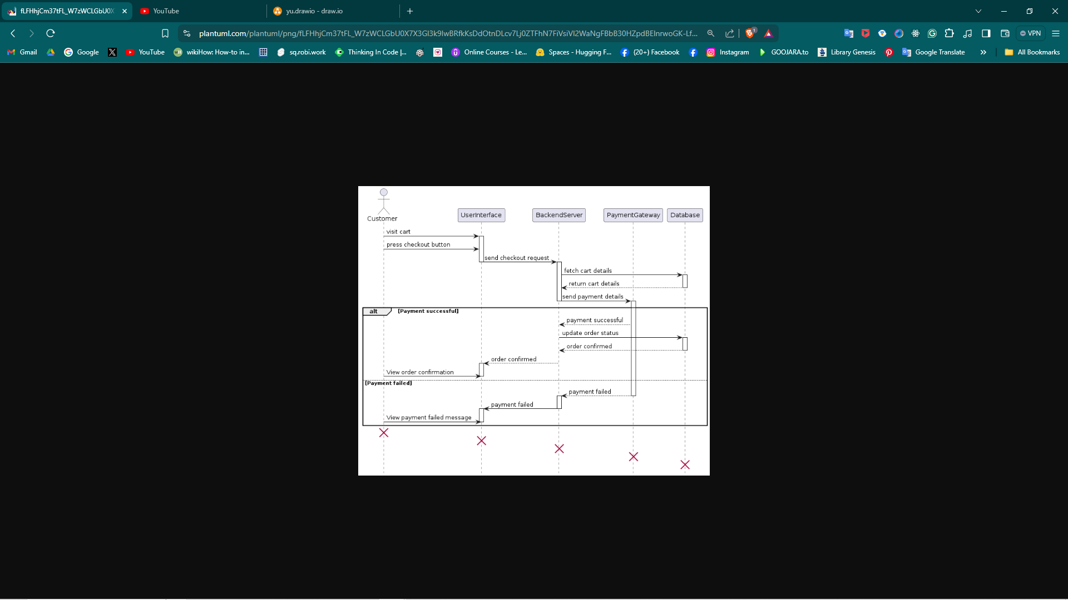

Figure 3.12 Sequence diagram of checkout

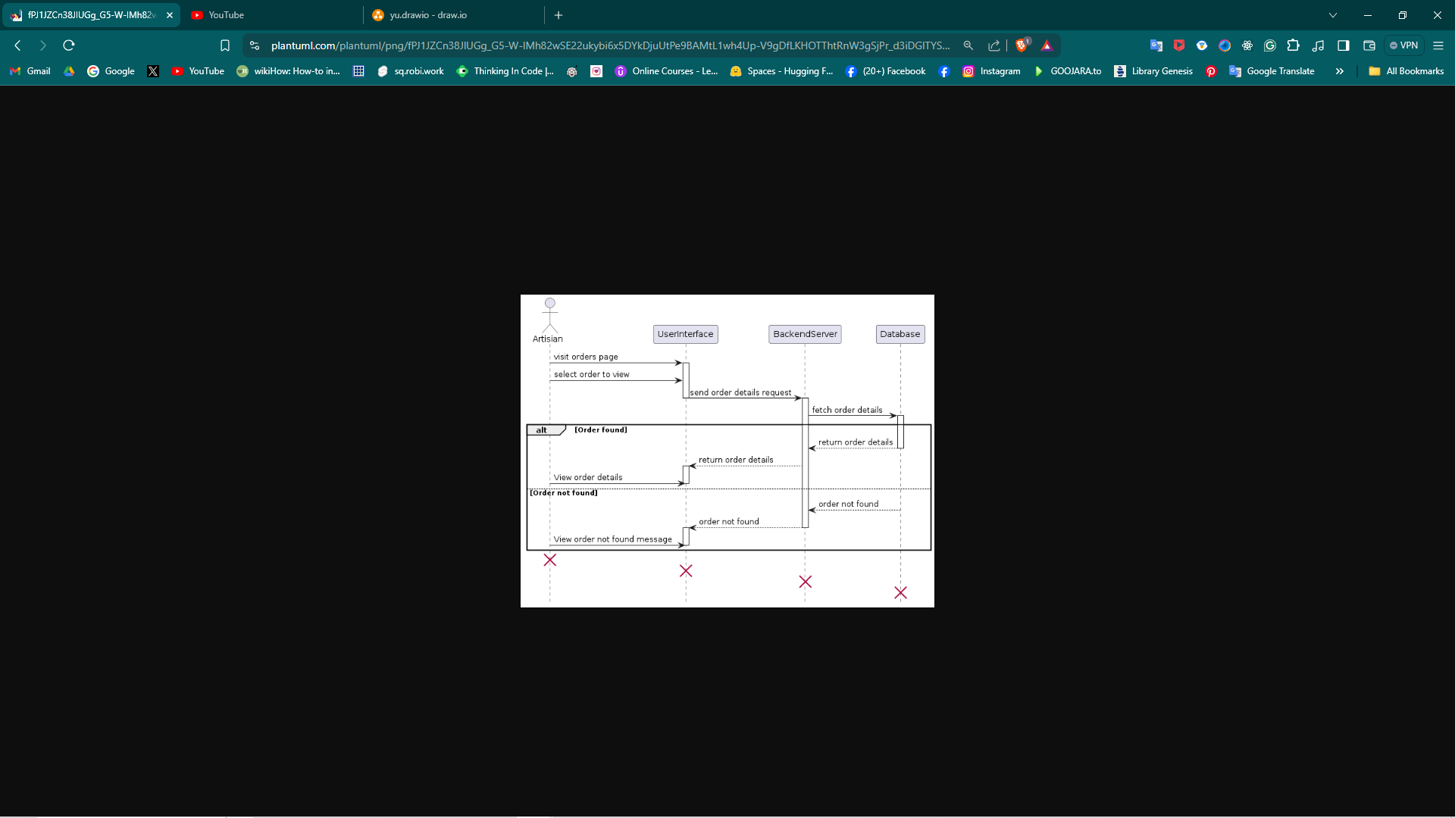

Figure 3.13 Sequence diagram of view order

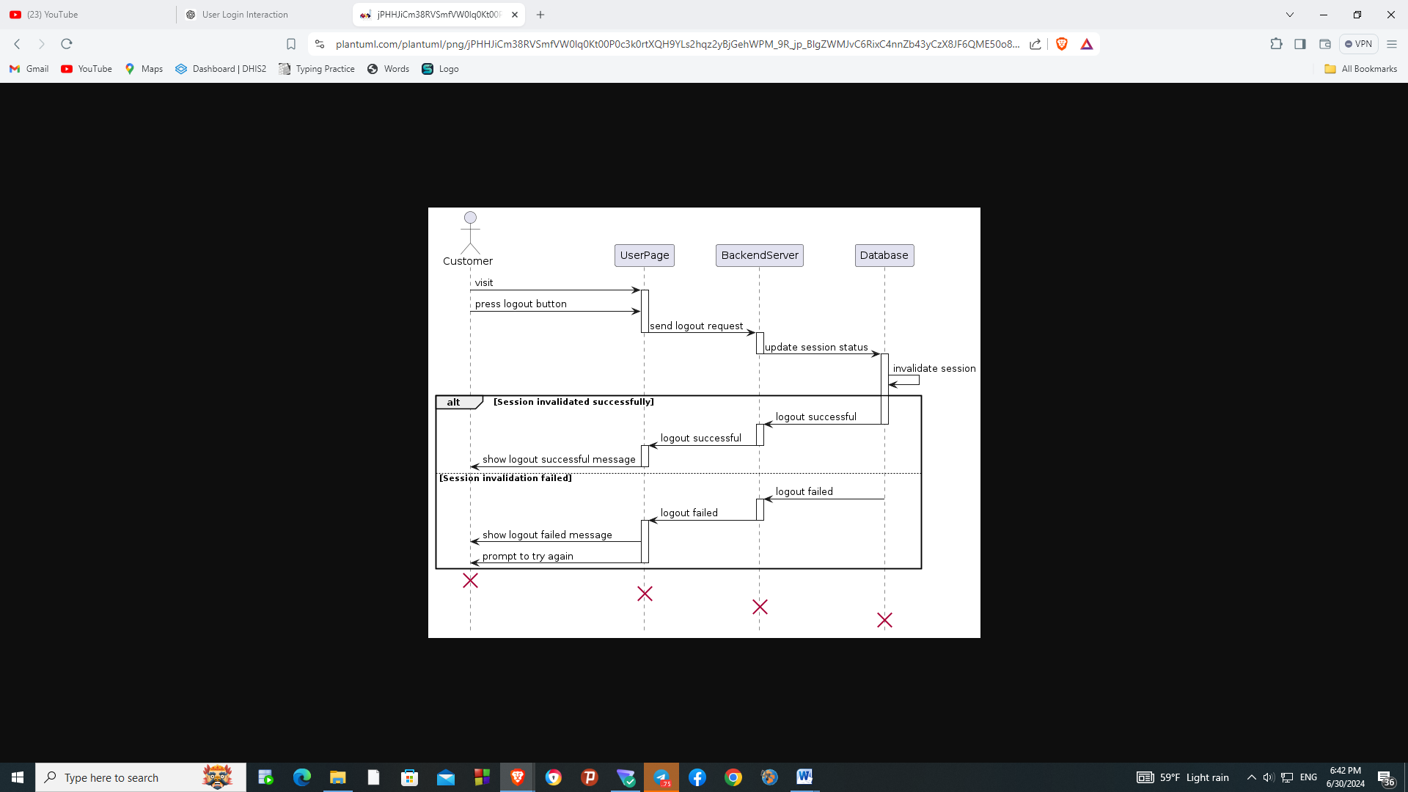

Figure 3.14 Sequence diagram of logout

### Activity Diagram

An activity diagram is a graphical representation of workflows of stepwise activities and s with support for choice, iteration, and concurrency. It shows the flow from one activity to another, illustrating the dynamic aspects of the system. Activity diagrams are used to model the workflow of a business process or the detailed steps in a use case [5].

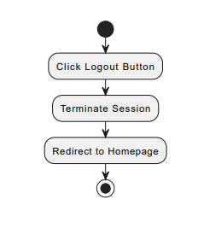

Figure 3.15 Logout Activity Diagram

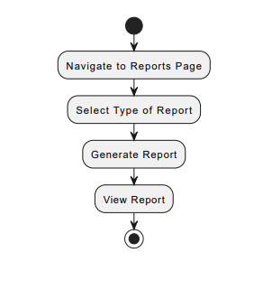

Figure 3.16 View Report Activity Diagram

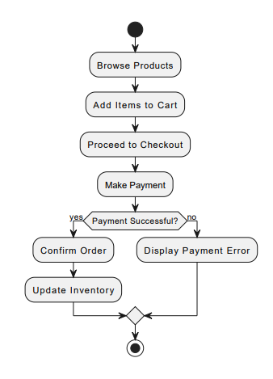

Figure 3.17 Order Product Activity Diagram

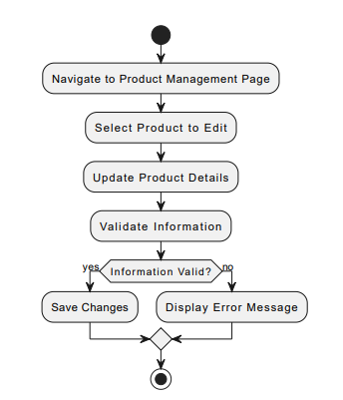

Figure 3.18 Edit Product Activity Diagram

.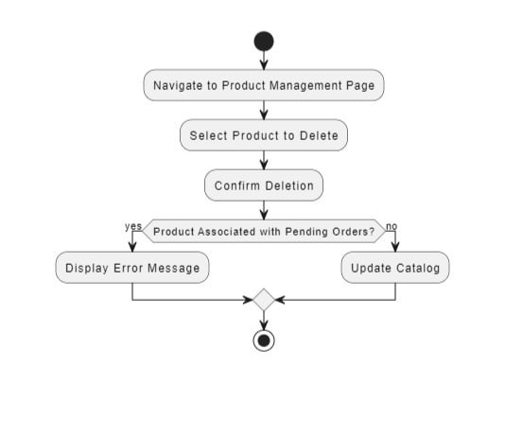

Figure 3.19 Delete Product Activity Diagram

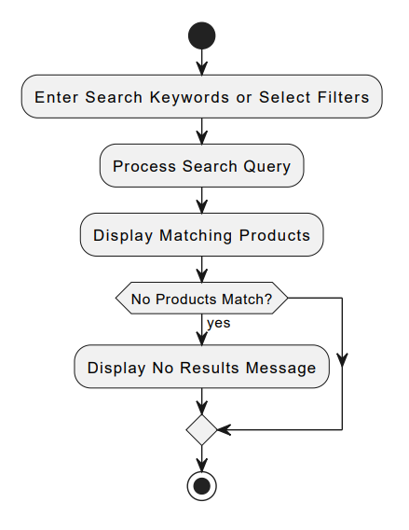

Figure 3.20 View Product Activity Diagram

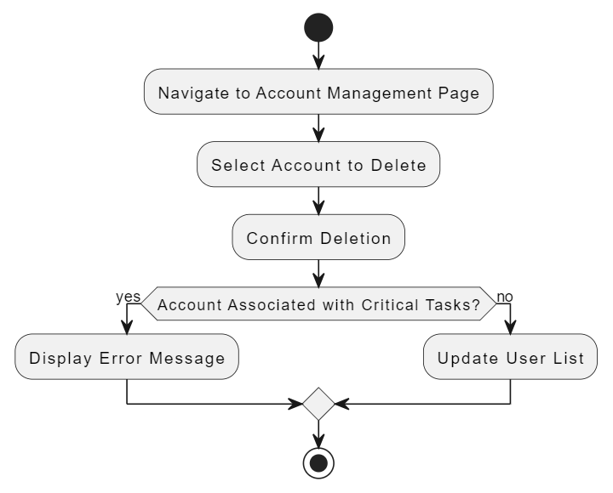

Figure 3.21 Delete Account Activity Diagram

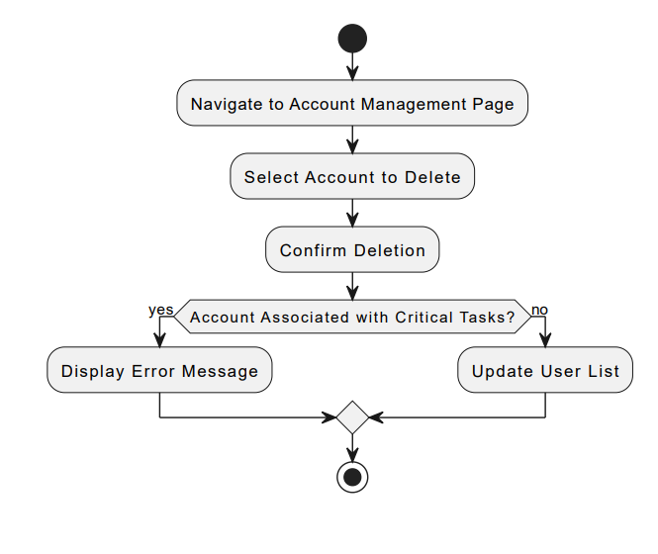

Figure 3.22 Add Staff Account Activity Diagram

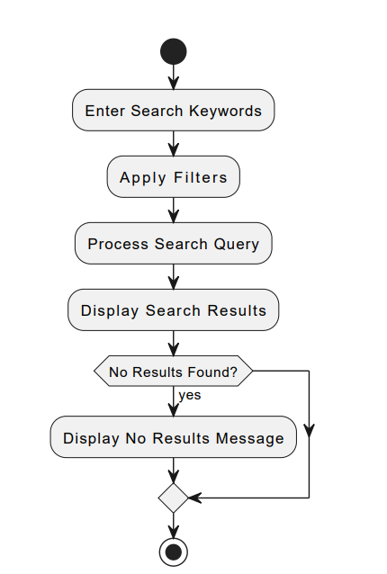

Figure 3.23 Search Activity Diagram

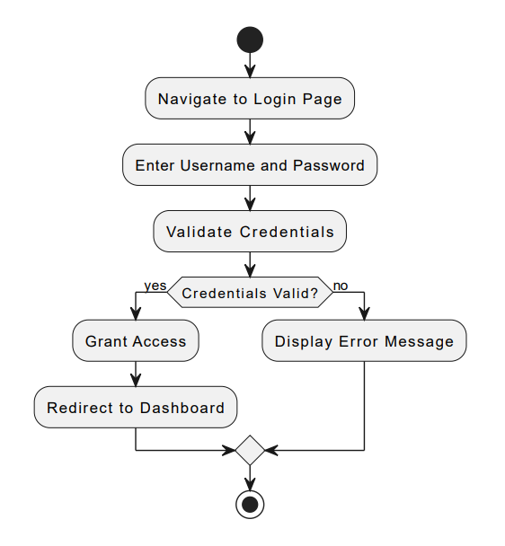

Figure 3.24 Login Activity Diagram

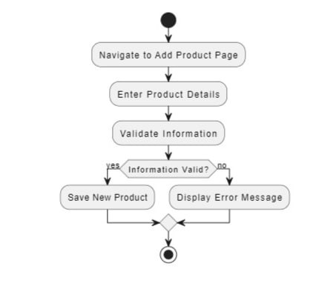

Figure 3.25 Add Product Activity Diagram

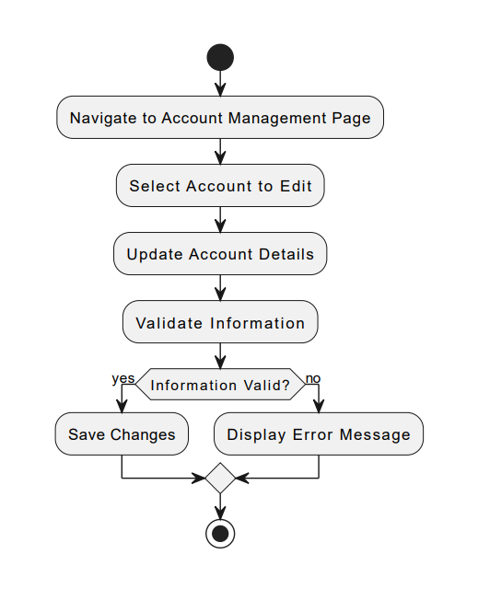

Figure 3.26 Edit Account Activity Diagram

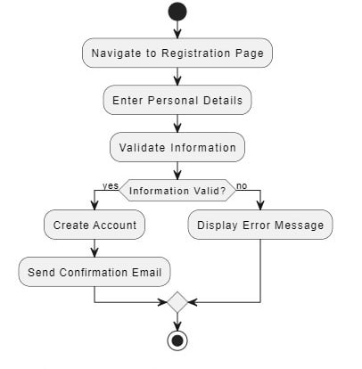

Figure 3.27 Register Activity Diagram

### Class Model

A class diagram is a type of static structure diagram that describes the structure of a system by showing its classes, attributes, methods, and the relationships among objects. Class diagrams are essential for modelling the static view of an application, defining the types of objects and their relationships [6].

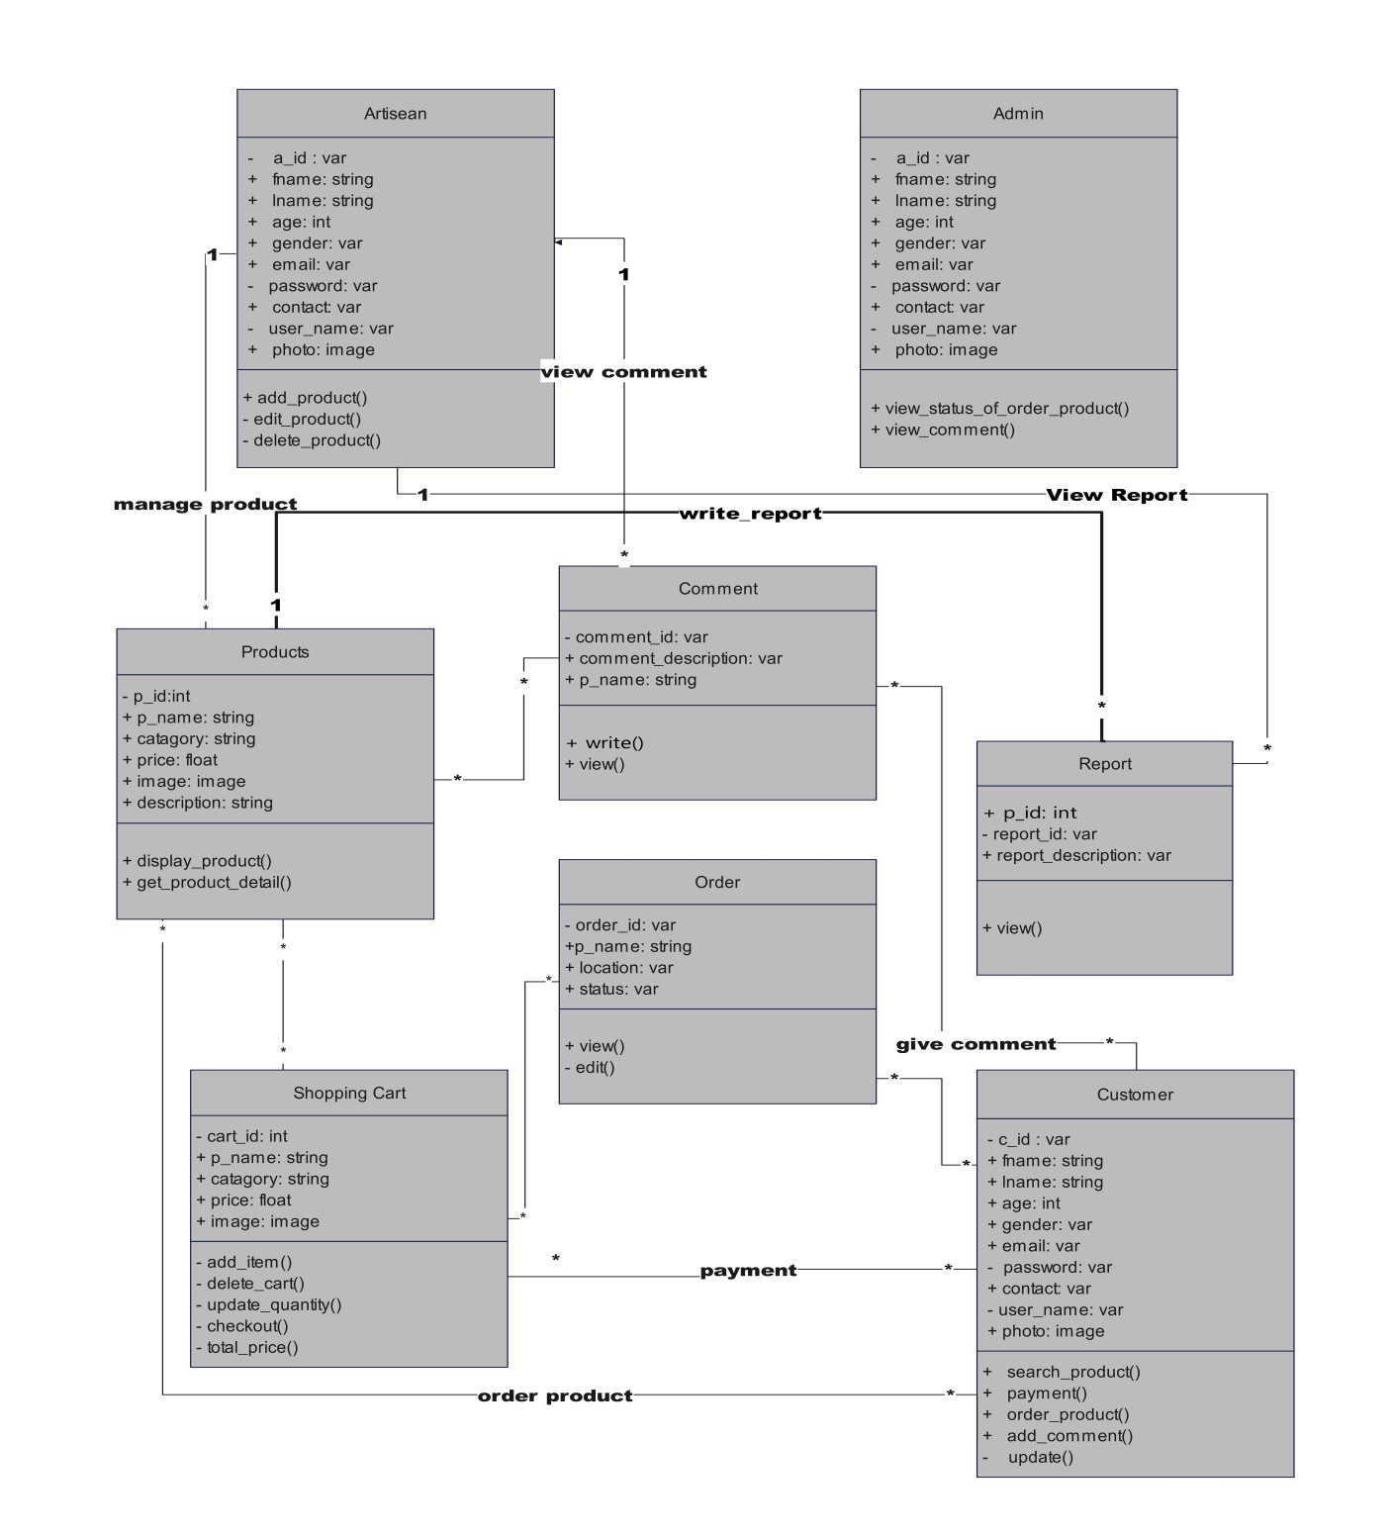

Figure 3.28 Class diagram

### Dynamic Modelling

Dynamic modelling involves real-time updates and feedback for user inters, such as adding items to the cart and processing orders. This approach ensures that the system responds promptly to user Actions, providing a smooth and responsive experience. Order processing will be managed from creation to fulfilment, with status updates keeping users informed throughout the process. Artisans will manage their product listings, ensuring that the platform remains current and accurate.

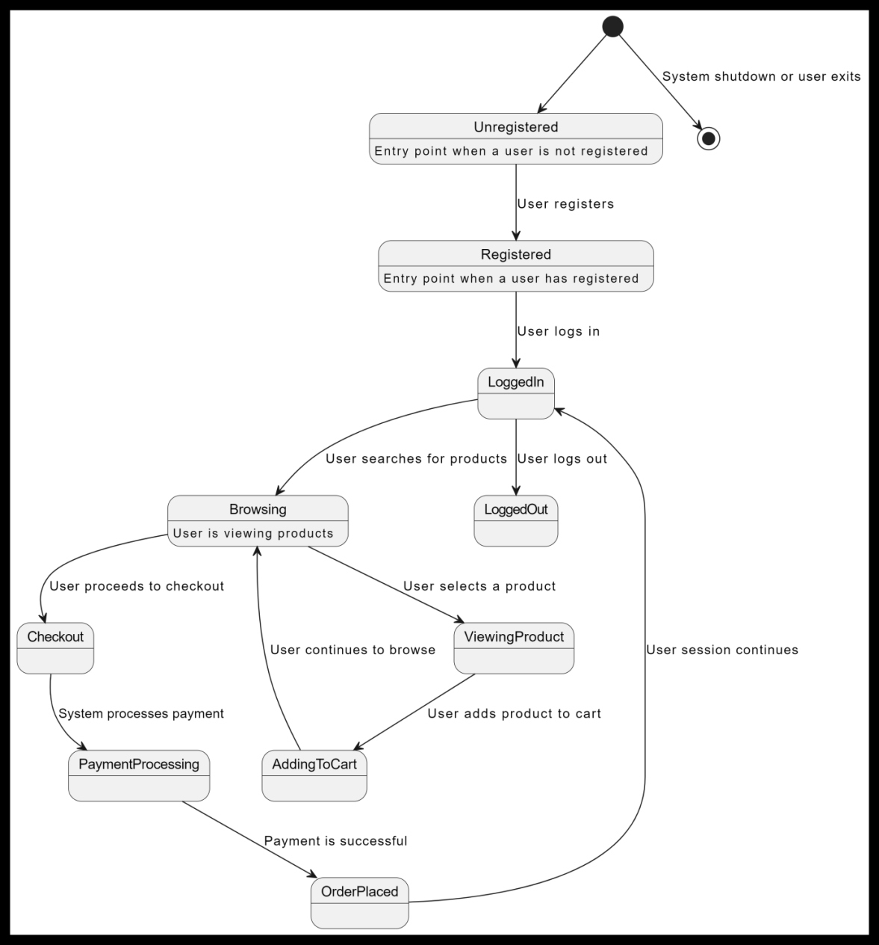

Figure 3.29 Dynamic model

### User Interface

The user interface will be designed to provide an intuitive and user-friendly experience. The home page will display featured products, categories, and a search bar, serving as an entry point for users to explore the platform. The product page will show detailed information about individual products, including images, descriptions, and prices, with an option to add items to the shopping cart. The cart page will list selected products, quantities, and total prices, with a checkout button to complete the purchase. The user dashboard will provide personalized areas for artisans to manage products and track orders, and for customers to view order history and account settings.

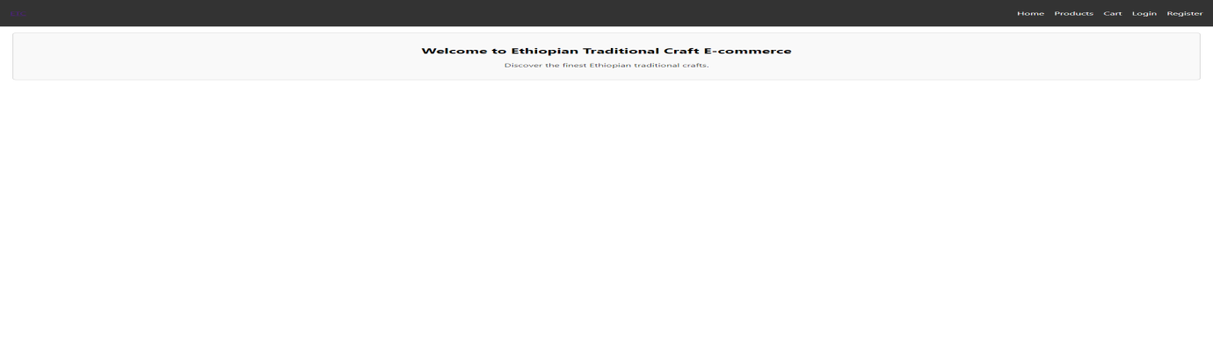

Figure 3.30 Home page

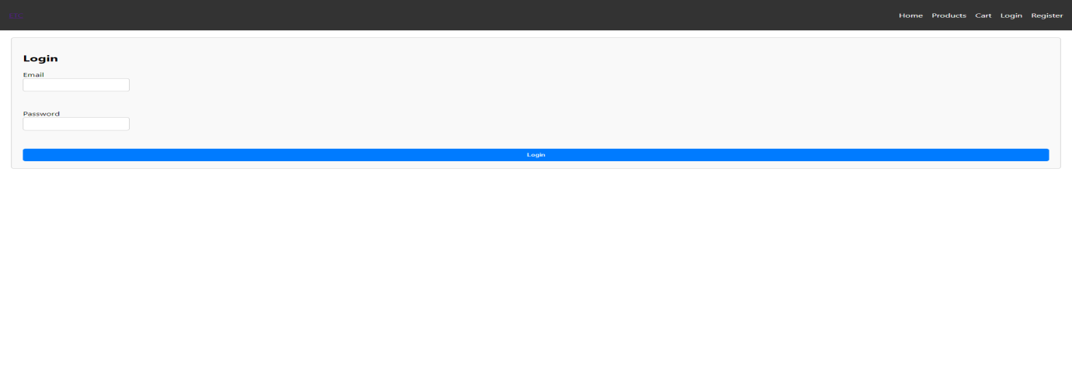

Figure 3.31 Login form

# Chapter 4

# System Design

## Introduction

This chapter describes the architectural and design principles for the development of the e-commerce platform. The design aims to create a scalable, secure, and user-friendly system that meets the needs of both artisans and customers.

## Purpose of the System

The purpose of the system is to create an online marketplace that connects Ethiopian artisans with a global customer base. By facilitating online sales, the platform aims to enhance artisans' market reach and income potential, helping to preserve traditional crafts and cultural heritage.

## Design Goals

* **User-Centric Design**: Create an intuitive and user-friendly interface for both artisans and customers.
* **Scalability**: Ensure the system can handle growing numbers of users and Trans.
* **Security**: Implement robust security measures to protect user data and Trans.
* **Reliability**: Provide high uptime and consistent performance.
* **Maintainability**: Design the system for easy updates and maintenance.

## Proposed Software Architecture

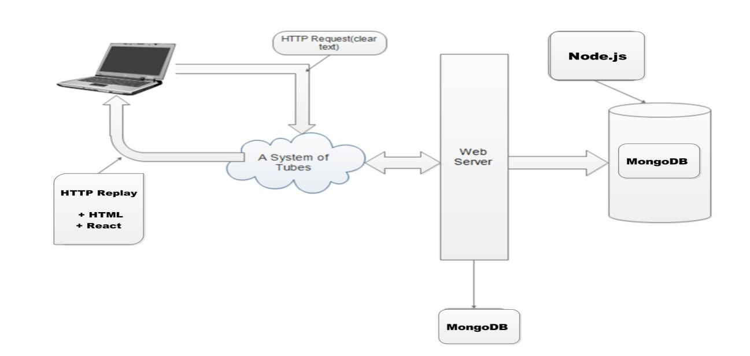

Figure 4.1 System architecture

### System Decomposition

The proposed software architecture will be divided into three main components: the frontend, the backend, and the database. The frontend will be built with React.js, providing responsive and dynamic user interfaces. The backend will be implemented with Node.js, handling business logic and APIs, while MongoDB will be used for storing user, product, and trans data.

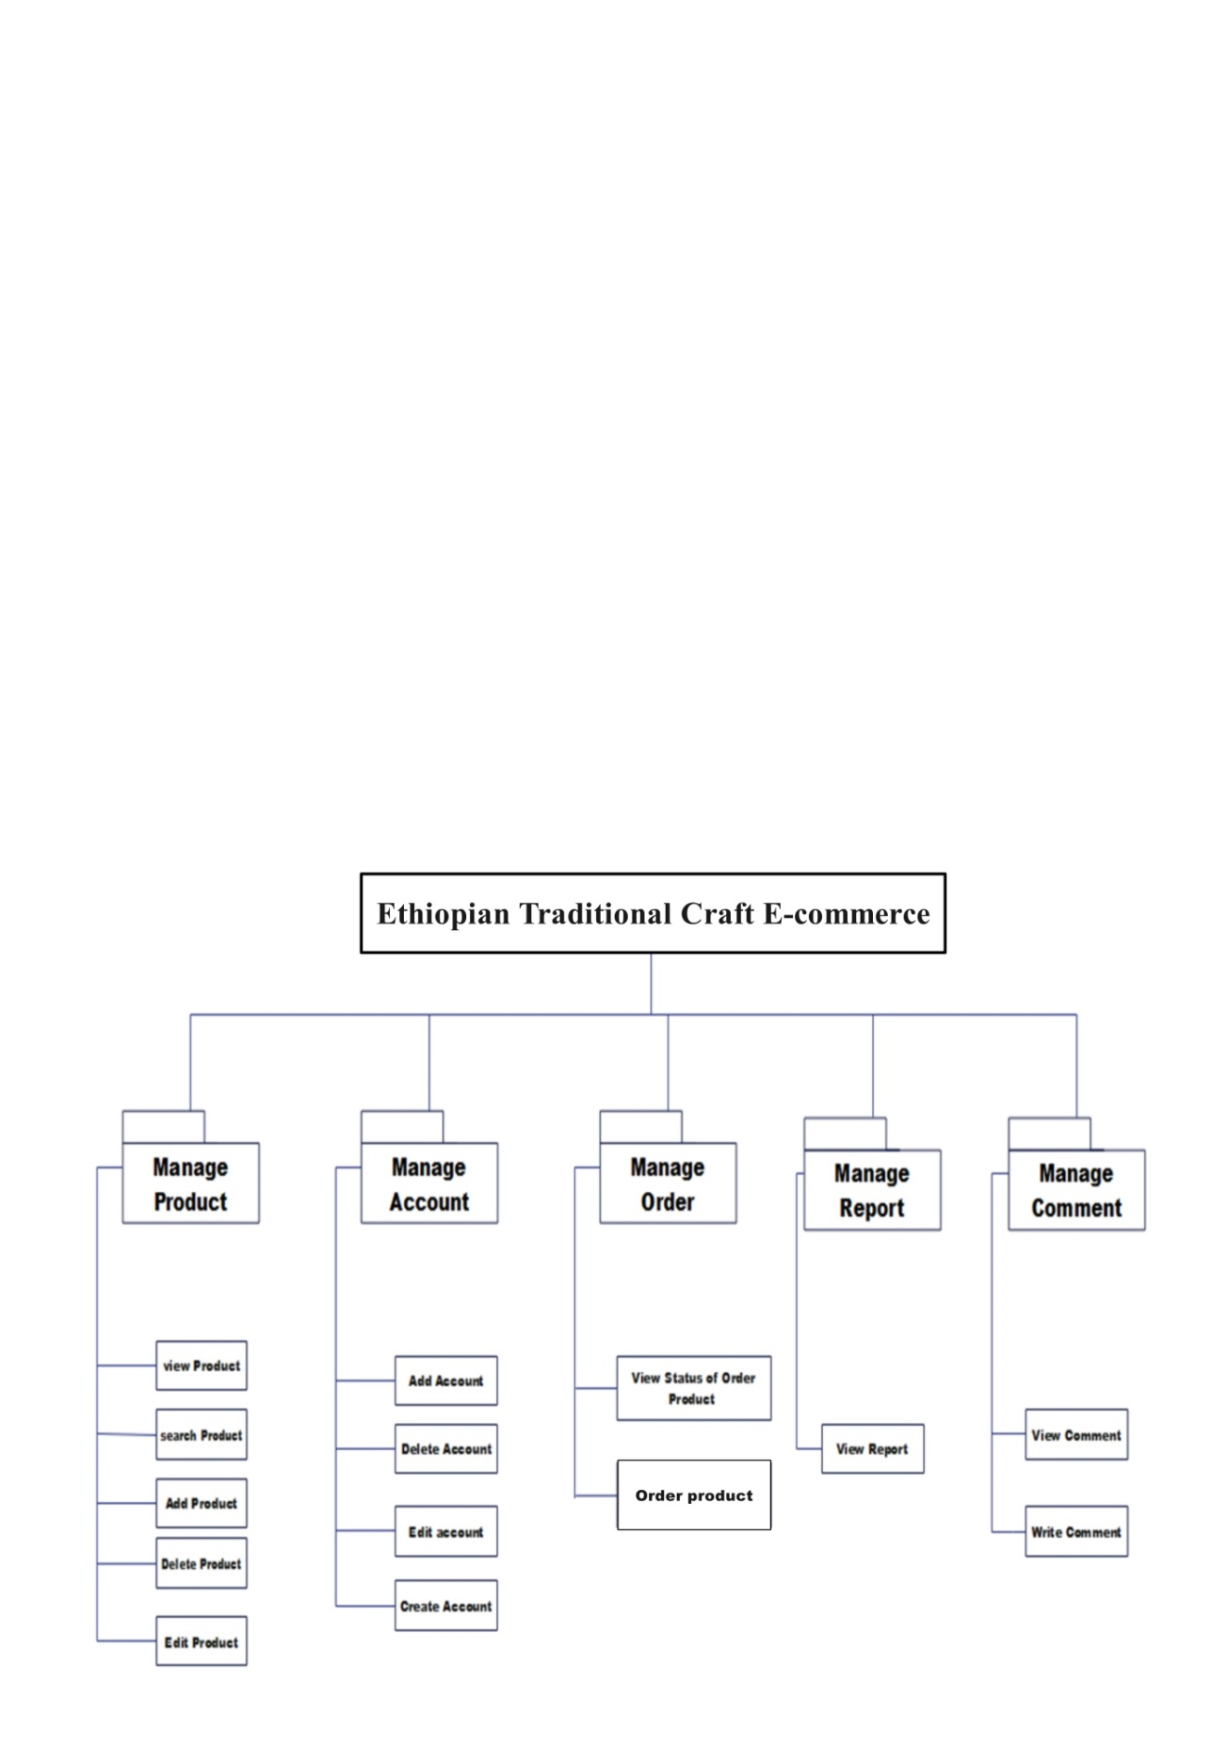

Figure 4.2 System Decomposition diagram

#### Proposed Software Architecture

The proposed software architecture follows a three-tier model consisting of:

1. **Presentation Layer**: Handles user inters through a web interface.
2. **Business Logic Layer**: Processes user requests, manages data, and enforces business rules.
3. **Data Access Layer**: Manages database inters and ensures data integrity.

### Hardware/Software Mapping

The frontend will be hosted on a web server, serving the user interface to clients. The backend will be deployed on a cloud-based server, handling processing and data management, while the database will be managed by a cloud database service, providing scalable and reliable data storage solutions.

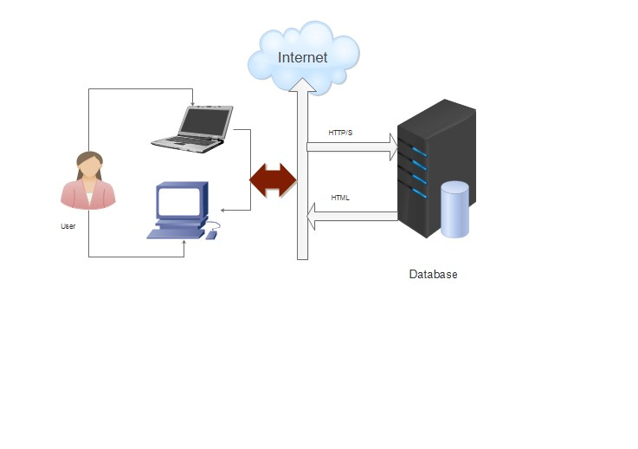

Figure 4.3 Hardware/Software Mapping

**Hardware**

* **User Devices**: Computers, tablets, and smartphones.
* **Web Server**: Cloud-based server hosting the frontend.
* **Application Server**: Cloud-based server running the backend services.
* **Database Server**: Cloud-managed MongoDB instance.

**Software**

* **Frontend**: React.js
* **Backend**: Node.js, Express.js
* **Database**: MongoDB

### Access Control and Security

**Access Control**:

* **Role-Based Access Control (RBAC)**: Different roles (admin, artisan, customer) with specific permissions.
* **JWT Authentication**: Secure user authentication and session management.

**Security Measures**:

* **Data Encryption**: Encrypt sensitive data both at rest and in transit.
* **Regular Security Audits**: Conduct periodic security assessments and updates.
* **Secure Payment Processing**: Integrate with compliant payment gateways (e.g., Chapa) for secure Trans.

### Deployment Diagram

The deployment diagram will provide a visual representation of the system's deployment architecture, showing how software components are distributed across hardware nodes.

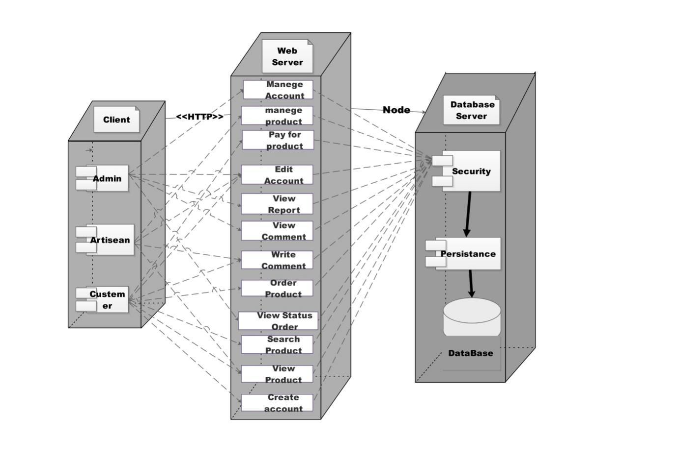

Figure 4.4 Deployment Diagram

# ****Conclusion****

**Our project focuses on developing a robust e-commerce platform tailored for Ethiopian traditional craft artisans and customers. It combines a thorough analysis of existing systems with detailed functional and non-functional requirements to create a user-friendly, scalable, and secure platform. Key functionalities include comprehensive account management, product and order handling, secure payment gateways, efficient search and browsing, and effective communication tools. The platform is designed to perform efficiently, maintain high availability, support future growth, and integrate seamlessly with third-party services. This project aims to enhance the online presence of Ethiopian artisans, providing them with the tools to manage their businesses effectively and offering customers an intuitive and reliable shopping experience for traditional crafts.**

# ****Reference****

1. **"Ethiopia," Encyclopedia Britannica, [Online]. Available: https://www.britannica.com/place/Ethiopia. [Accessed: 28-Jun-2024].**
2. **D. A. Shiferaw and A. A. Bezabih, "Market Access and Income Growth: The Case of Rural Households in Ethiopia," Journal of Agricultural Economics, vol. 64, no. 3, pp. 530-552, 2013. [Online]. Available: https://doi.org/10.1111/1477-9552.12034.**
3. **S. Z. Wossen, T. Berger, T. Mequaninte and J. H. Alamirew, "Social network effects on the adoption of sustainable natural resource management practices in Ethiopia," International Journal of Sustainable Development & World Ecology, vol. 20, no. 6, pp. 477-483, 2013. [Online]. Available: https://doi.org/10.1080/13504509.2013.856048.**
4. **I. Jacobson, G. Booch, and J. Rumbaugh, "The Unified Software Development Process," Addison-Wesley Professional, 1999.**
5. **OMG, "Unified Modeling Language (UML) Superstructure Specification," version 2.4.1, Object Management Group, Aug. 2011.**
6. **B. Meyer, "Object-Oriented Software Construction," 2nd ed., Prentice Hall PTR, 1997.**